***360 Café and Outlet***



Author

Adnan Imam 1108137

Baloch Khan 1108169

Fahad Rahim 1107430

Supervisor

Bilal Ur Rehman

Lecturer

DEPARTMENT OF COMPUTER SCIENCE

FACULTY OF SCIENCE AND ENGINEERING

UNIVERSITY OF TURBAT

January, 2026

Project Title

***360 Café and Outlet***

Author

Adnan Imam 1108137

Baloch Khan 1108169

Fahad Rahim 1107430

A report submitted in partial fulfillment of the requirements for the degree of

**BS Computer Science**

**Project Supervisor:**

**Bilal Ur Rehman**

**Lecturer**

**Department of Computer Science**

Head of The Department Signature: ____________________

Supervisor Signature:___________________

DEPARTMENT OF COMPUTER SCIENCE

FACULTY OF SCIENCE AND ENGINEERING UNIVERSITY OF TURBAT

January, 2026

# DEDICATION

We dedicate this project in the name of **Allah the Almighty** who is present when we are planning and whose preciseness fulfills our dream.

Special dedication also to our **Parents**, whose prayers, love, support, and motivation are with us in each moment of life. Their sacrifices have been the silent force behind our success.

Furthermore, we love to dedicate this work to our respected **Teachers** of the Computer Science Department, our **Best Friends,** **Supportive Students of University of Turbat (UoT),** and all our class fellows for the continual impact of knowledge and encouragement.

Finally, we dedicate this project to our **Supervisor** and the **Head of the Computer Science Department** for their motivation, guidance, and unwavering support throughout the development of **360 Cafe and Outlets.**

# Abstract

***360 Café and Outlets***

The "360 Cafe and Outlets" project abstracts the complexities of running a digital food business into a simple, three-tier interaction model. By decoupling the consumption layer (Customer App) from the management layer (Shop Owner App) and the processing layer (Backend Services), the system provides a seamless conduit for local commerce. Complex implementation details like database transactions, authentication tokens, and routing logic are hidden behind intuitive user interfaces, allowing non-technical stakeholders to leverage advanced technology effectively. The microservices abstraction further isolates domains, ensuring that a failure in the "Reviews" module does not critically impact the core "Ordering" capability.

# UNDERTAKING

I certify that research work titled 360 Café and Outlet is my own work. The work has not been presented elsewhere for assessment. Where material has been used from other sources it has been properly acknowledged / referred.

|  |  |  |  |
| --- | --- | --- | --- |
| **Serial No** | **Student Name** | **Registration No** | **Signature** |
| 1 | Adnan Imam | 1108137 |  |
| 2 | Baloch Khan | 1108169 |  |
| 3 | Fahad Rahim | 1107430 |  |

# ACKNOWLEDGEMENTS

Thanks to Allah the Rahman and Merciful, whose help covers the entire universe, whose powers are indefinable, and who guided us to complete our project under Mr. Bilal ur Rahman’s supervision with his encouragement and guidance.

We are incredibly grateful to our supervisor for his vision and his persistence upon the values of hard work on this project. Without him, it may not have been possible to complete 360 Cafe and Outlets within the limited duration.

We would also like to express our deep respect to Dr. Rashid Ali, Mr. Mamoon Rasheed, and all other faculty members of the Computer Science Department for their support and the valuable time they invested in us.

Furthermore, it has been a beautiful journey with our classmates and the faculty of the Computer Science Department and others as well.

Lastly, we would like to thank our institute, University of Turbat, for providing us a platform to build such an impactful project within the Turbat environment. This achievement would not have been possible without this supportive ecosystem.

Table of Contents

Abstract iii

UNDERTAKING iv

CHAPTER 1 1

Introductory Chapter 1

Introduction 1

1.1.1 Purpose 1

1.1.2 Description 2

1.1.3 Document Conventions 3

1.1.4 Product Scope 3

1.1.5 Functional Requirements 4

1.1.6 Intended Audience and Reading Suggestions 5

1.1.6.1 Customers (Students, Faculty, and Public) 5

1.1.6.2 Shop Owners and Kitchen Staff 5

1.1.6.3 Official Documentation 5

1.1.6.4 Online forums or communities 5

1.2 Overall descriptions 6

1.2.1 Product Perspective 6

1.2.2 Product Features 6

1.2.3 User Classes and Characteristics 6

1.2.4 Operating Environment 7

1.2.5 Design and Implementation Constraints 7

1.2.6 Assumptions and dependencies 7

1.3 External Interface Requirements 8

1.3.1 User interface 8

1.3.2 Internet Connectivity 8

1.3.3 Hardware Interfaces 8

1.3.4 Software Interfaces 8

1.4 System Features 9

1.4.1 System Feature 9

1.4.2 Behavioral Diagram 9

1.5 Other Non-functional Requirements 9

CHAPTER 2 11

Literature Review 11

Literature Review 11

2.1 Introduction 11

2.2 Existing Solutions 11

2.2.1 Foodpanda 11

2.2.2 Cheetay 12

2.2.3 WhatsApp / Phone Ordering 12

2.2.4 Manual Queuing (Traditional Method) 12

CHAPTER 3 14

3.1.1 Introduction 14

3.1.2 Design Phase 14

3.1.3 Implementation Phase 14

3.1.4 Testing Phase 14

3.1.5 Evaluation Phase 15

3.2 System Architecture 15

3.3 Hardware and Software Requirements 15

3.3.1 Hardware Requirements 15

3.3.2 Software Requirements 16

3.4 Software Design 16

3.4.1 Style Guide 16

3.4.2 Color Palette 16

3.4.3 Icons 17

3.5 Use Cases Description 17

3.5.1 Consumer (Customer) 17

3.6 Final Interfaces 17

3.6.1 Get Started Screen Interface 18

3.6.2 Registration / Login 18

3.6.3 Create/Change PIN (Profile Security) 18

3.6.4 Home Screen Interface (Shop Discovery) 18

3.6.5 Product Details Screen Interface 18

3.6.6 Cart Screen Interface 19

3.6.7 Order History Interface 19

3.6.8 Notifications Screen Interface 19

3.6.9 User Profile Screen Interface 19

3.6.10 Vendor Dashboard (Shop Owner) 19

3.6.11 Kitchen View (Order Fulfillment) 20

CHAPTER 4 21

Implementation 21

4.1 Purpose 21

4.2 Scope 21

4.2.1 Customer Application (Mobile) 21

4.2.2 Shop Owner Application (Mobile/Tablet) 22

4.2.3 Backend Microservices 22

4.3 Overview 23

4.4 System Overview 24

4.4.1 Software Architecture 24

4.4.2 Technology Stack Details 24

4.4.3 Infrastructure & Deployment 25

2.2 Table Style 26

REFERENCES 27

# 

# LIST OF FIGURES

|  |  |
| --- | --- |
| **Figure No.** | **Figure Description** |
| 1.1.5  3.1.1  3.6.1.1 | Gantt Chart  Agile Process Model  Shop Owner Registration Screen |
| 3.6.1.2 | Email Verification Screen |
| 3.6.1.3 | Shop Owner Login Screen |
| 3.6.1.4 | Shop Creation Request Screen |
| 3.6.1.5 | Shop Owner Details Screen |
| 3.6.1.6 | Shop Details Screen |
| 3.6.1.7 | Terms and Conditions Screen |
| 3.6.1.8 | Vendor Dashboard Overview |
| 3.6.1.9 | Order Management Screen |
| 3.6.2.0 | Menu Management Screen |
| 3.6.2.1 | My Shop (Storefront Management) Screen |
| 3.6.2.2 | Reviews Screen |
| 3.6.2.3 | Add Product and Category Screen |
| 3.6.3.1 | Customer Sign-In Screen |
| 3.6.3.2 | Complete Profile Screen |
| 3.6.3.3 | Customer Home (Discovery) Screen |
| 3.6.3.4 | Shop Details and Menu Screen |
| 3.6.3.5 | Checkout Screen |
| 3.6.3.6 | Orders Tracking Screen |
| 3.6.3.7 | User Profile Screen |
| 3.6.4.1 | Entity Relationship (ER) Diagram |
| 3.6.4.2 | State Diagram of User Registration |
| 3.6.4.3 | State Diagram of Shop Discovery and Order Placement |
| 3.6.4.4 | State Diagram of Shop Owner Registration |
| 3.6.4.5 | State Diagram of Shop Creation and Order Receiving |

# CHAPTER 1: Introductory Chapter

## 1 Introduction

The rapid evolution of mobile technology has fundamentally transformed the service industry, reshaping how consumers interact with businesses. The food and beverage sector, in particular, has seen a paradigm shift towards digital ordering systems that prioritize convenience, speed, and efficiency. However, in many developing regions and semi-closed environments like universities and corporate hubs in Turbat, the adoption of such technologies has been slow.

360 Cafe and Outlets is a robust, multi-vendor e-commerce solution specifically engineered to modernize the traditional cafeteria experience within the Turbat region. By replacing the archaic manual ordering processes with a sophisticated mobile-first ecosystem, the system bridges the operational gap between hungry customers and cafeteria vendors. Leveraging a microservices architecture underpinned by Node.js and Flutter, the platform offers a seamless, cashless, and highly efficient ordering experience. This document serves as a comprehensive guide to the development, architecture, and deployment of the "360 Cafe and Outlets" system, detailing how it addresses specific local challenges while adhering to global software engineering standards.

## 1.1.1 Purpose

The primary purpose of 360 Cafe and Outlets is to digitize the entire lifecycle of food ordering and management within food courts, university campuses, and corporate cafeterias in Turbat. The system is designed to serve multiple stakeholders with distinct benefits:

* **For Customers (Information & Convenience):** To provide a unified platform where users can browse menus from multiple outlets, view real-time item availability, place orders without standing in line, and track their order status from "Pending" to "Ready" instantly.
* **For Shop Owners (Operational Efficiency):** To empower local vendors with digital tools that streamline inventory management, automate order taking, reduce human error in kitchen communication, and provide actionable insights into daily sales performance.
* **For Administration (Modernization):** To introduce a scalable, cashless transaction model that reduces congestion in food courts and enhances the modern image of the institution or facility.

## 1.1.2 Description

360 Cafe and Outlets is a cohesive ecosystem comprising three distinct but interconnected components, tailored for closed-loop or semi-public food environments:

1. **Customer Application (Flutter):** A cross-platform mobile application that serves as the customer's digital interface. It features:
   * **Smart Discovery:** Server-side search and categorization to easily find shops and products.
   * **Live Menu:** Real-time synchronization of prices and availability.
   * **Order Management:** A comprehensive cart and checkout system with real-time status tracking via socket-based notifications.
2. **Shop Owner Application (Flutter):** An administrative dashboard for vendors, accessible via mobile or tablet. It allows vendors to:
   * **Manage Digital Storefronts:** Toggle shop status (Open/Closed) and update profiles.
   * **Menu Engineering:** Dynamically add, edit, or remove products and categories.
   * **Order Fulfillment:** A dedicated "Kitchen View" to manage the lifecycle of incoming orders.
3. **Backend Infrastructure (Node.js & PostgreSQL):** The backbone of the system, built on a modular microservices architecture. It includes:
   * **Auth Service:** secure JWT-based authentication.
   * **Shop & Product Services:** Handling catalog data with advanced search capabilities.
   * **Order Service:** Managing high-concurrency transactions and state transitions.
   * **Database:** A relational PostgreSQL database ensuring ACID compliance for reliability.

## 1.1.3 Document Conventions

This document follows standard IEEE 830-1998 guidelines for Software Requirements Specifications.

Typography: Bold text is used for specific term definitions, UI elements, and emphasis. Code snippets and file paths are formatted in `monospace`.

Prioritization: Requirements are implicitly prioritized as Essential (MVP) unless marked as Optional or Future Scope.

Diagrams: Data flow and state diagrams are described textually or using Mermaid syntax.

## 1.1.4 Product Scope

The scope of the 360 Cafe and Outlets project is defined by the following boundaries:

* **In-Scope:**
  + **User Authentication:** Secure signup/login for Customers and Shop Owners, including profile management.
  + **Multi-Vendor Support:** The system supports an unlimited number of distinct shops on a single platform.
  + **Catalog Management:** Complete CRUD (Create, Read, Update, Delete) operations for categories and products.
  + **Ordering Workflow:** End-to-end handling of orders including cart management, placement, validation, and status updates.
  + **Notification System:** Real-time alerts for order confirmations, preparation updates, and pickup readiness.
  + **Search Engine:** Optimized server-side search for detecting shops and products across the platform.
* **Out-of-Scope:**
  + **Third-Party Logistics:** The system is designed for "Pick-Up" and "Dine-In" models typical of food courts. Integration with external delivery riders (like UberEats) is outside the current scope.
  + **Payment Gateway Integration:** While the system calculates totals, the actual payment processing (Credit Card/Bank APIs) is simulated for this iteration, focusing on the order workflow itself.

## 1.1.5 Gantt Chart

## 

Figure 1.1.5

## 1.1.6 OBJECTIVES AND PROBLEM STATEMENT

**1. Problem Statement**

The educational and corporate sectors in Turbat are undergoing a rapid digital transformation, yet the food service industry within these institutions remains tethered to archaic, manual operational models. The University of Turbat, being a hub of intellectual growth for hundreds of students and faculty, faces significant logistical challenges during peak dining hours. The absence of a streamlined, technology-driven ordering system creates a ripple effect of inefficiency that impacts every stakeholder in the ecosystem—from the hungry student to the stressed cafeteria vendor.

The core problems identified in the current manual setup are multifaceted:

**1.1. Physical Congestion and Time Wastage**

The most visible symptom of the current system is the chaotic "lunch rush." During short break intervals (typically 30-60 minutes), hundreds of students converge on a few cafeteria outlets.

The Queue Effect: Students are forced to stand in long physical lines just to place an order, often waiting 15-20 minutes before they can even speak to a cashier.

The Waiting Game: After ordering, they must wait again for the food to be prepared, often hovering around the counter in a disorganized crowd.

Impact: This physical congestion obstructs pathways, creates a noisy and stressful environment, and significantly eats into the students' limited relaxation time. Many students choose to skip meals entirely rather than endure the chaos, resulting in lost revenue for vendors.

**1.2. Inefficient Order Taking and Processing**

The reliance on verbal communication and handwritten slips is fundamentally flawed in a high-noise environment.

Human Error: In the din of a crowded cafeteria, orders are frequently misheard (e.g., "Chicken Burger" vs. "Beef Burger"), leading to food waste and customer dissatisfaction.

Lack of Synchronization: There is often a disconnect between the person taking the money and the kitchen staff preparing the food. Orders get lost, skipped, or prepared out of sequence, violating the First-In-First-Out (FIFO) principle and causing unfair delays for customers.

**1.3. Inventory Visiblity and Disappointment**

In the current analog setup, a menu board is static. It does not reflect the real-time reality of the kitchen.

The "Out of Stock" Friction: A customer might wait 10 minutes in line, deciding on a specific meal, only to reach the counter and be told, "Sorry, that's finished." This leads to immediate frustration and often results in the customer leaving the queue entirely.

Waste Management: Conversely, vendors may over-prepare unpopular items because they lack a way to signal "Specials" or push slow-moving inventory effectively to the students.

**1.4. Operational Opacity (Data Invisibility)**

Perhaps the most critical business failure is the lack of data. Shop owners operate on intuition rather than intelligence.

No Analytics: Vendors cannot answer basic questions with certainty: What is my best-selling item? What is my busiest hour? How much revenue did I lose today due to slow service?

Blind Planning: Without historical data, inventory purchasing is a guessing game, leading to either spoilage (waste) or shortages (lost sales).

**1.5. Hygiene and Cash Dependencies**

The exclusive reliance on physical cash is a bottleneck and a health risk.

Transaction Velocity: Fumbling for change slows down the line significantly. A 30-second cash exchange per customer adds up to hours of lost service time over a day.

Hygiene: In a food environment, the same hands handling dusty currency notes are often involved in serving food, posing cross-contamination risks.

**2. Project Objectives**

The 360 Cafe and Outlets project aims to dismantle these inefficiencies through a comprehensive digital intervention. Our goal is not merely to build an "app," but to engineer a Cyber-Physical System that harmonizes the digital flow of information with the physical flow of food preparation.

**2.1. Primary Objectives (Functionality & Impact)**

**1. Drastic Reduction in Wait Times (The "Zero-Queue" Goal)**

The primary metric of success is time. We aim to reduce the total "Order-to-Eating" time by at least 40%.

Strategy: By decoupling the ordering process from the physical location, students can place orders from their classrooms 10 minutes before the break starts.

Outcome: When the student arrives at the cafeteria, their food is already in the "Preparing" or "Ready" stage, turning a 20-minute ordeal into a 2-minute pickup.

**2. Operational Synchronization via Kanban Workflow**

We aim to professionalize the kitchen operations.

Strategy: Replacing verbal shouting with a digital Kitchen Dashboard. Orders appear as cards that move from Pending $\rightarrow$ Preparing $\rightarrow$ Ready.

Outcome: This enforces a disciplined, linear workflow, reducing errors to near zero and ensuring that the kitchen remains calm and organized even during peak loads.

**3. Real-Time Inventory Management**

We aim to eliminate the "Out of Stock" disappointment.

Strategy: Providing Shop Owners with an instant "Toggle Switch" for every menu item.

Outcome: If an item runs out, the owner flips a switch, and it instantly disappears or grays out on the phones of 2,000 students. This creates a trust-based relationship where the digital menu is the single source of truth.

**2.2. Secondary Objectives (Ecosystem & Growth)**

**1. Data-Driven Business Intelligence**

To empower local vendors with enterprise-grade insights.

Goal: Provide automated daily reports showing Total Revenue, Order Counts, and Top **5 Products.**

Impact: Enabling vendors to optimize their stock purchasing and staffing based on actual demand trends.

**2. Scalability and Reliability**

To build a system that grows with the university.

Goal: The backend architecture (Microservices) must support horizontal scaling, capable of handling 500+ concurrent users without crashing.

Impact: Ensuring the system remains reliable (99.9% uptime) even as new shops and students join the platform.

**3. Modernization of Campus Culture**

To serve as a flagship project for digitization at UoT.

Goal: Creating a "Cashless-Ready" environment that encourages digital literacy.

Impact: Setting a precedent for future student projects and improving the modern image of the institution.

**2.3. Technical Objectives**

Latency: Ensure API response times are under 200ms to provide a "native" feel.

Cross-Platform: Deliver a consistent experience across Android (Customer) and Web (Shop Owner).

Security: Protect user PII (Personally Identifiable Information) with industry-standard encryption (Bcrypt, JWT, SSL).

## 1.1.7 Functional Requirements

The system is built to strictly adhere to the following functional requirements:

A. **Customer Module**

* **Secure Access:** Multi-factor authentication or secure password hashing for user accounts.
* **Smart Search:** A robust search engine allowing users to filter by "Shop Name", "Product Name", or "Category" (e.g., Fast Food, Desi).
* **Cart Persistence:** The ability to add items from different categories, update quantities, and clear the cart.
* **Order Lifecycle:** Users must receive transparent updates as their order moves from "Pending" -> "Preparing" -> "Ready".

B. **Shop Owner Module**

* **Operational Control:** A master switch to instantly toggle the shop's visibility (Open/Closed) based on real-time kitchen capacity.
* **Catalog Control:** Instant updates to the menu (adding specials, hiding out-of-stock items) that reflect immediately on the customer app.
* **Order Dashboard:** A live feed of incoming orders with action buttons to "Accept", "Mark Ready", or "Complete".

C. **System Module**

* **Real-time Synchronization:** Changes in the database must propagate instantly to connected clients (e.g., using WebSockets or Polling).
* **Data Validation:** The backend must sanitize all inputs to prevent SQL injection and ensure data integrity.

## 1.1.8 Intended Audience and Reading Suggestions

This document is designed for a diverse audience involved in the deployment, usage, and maintenance of the system.

### 1.1.8.1 Customers (Students, Faculty, and Public)

Usage: This group represents the primary end-users of the Customer App. They include university students, faculty members, and visitors in Turbat who wish to order food digitally. Suggestion: They should focus on Section 1.2.2 (Product Features) to understand how to use the "Smart Search", "Cart", and "Order Tracking" features to save time during breaks.

### 1.1.8.2 Shop Owners and Kitchen Staff

Usage: This group comprises the cafeteria vendors and their staff who will use the Shop Owner App. They are responsible for fulfilling orders and managing their digital menus. Suggestion: They should review Section 1.2.4 (Operational Environment) to understand the device requirements (tablets/laptops) and the Vendor Dashboard documentation to learn how to toggle their shop's "Open/Closed" status.

### 1.1.8.3 Official Documentation

Usage: For developers and IT staff responsible for maintaining the system or extending its functionality. Suggestion: This document serves as the primary reference. Developers should pay close attention to Chapter 3 (System Architecture) and Chapter 4 (Database Design).

### 1.1.8.4 Online forums or communities

Usage: For obtaining support on the underlying technologies (Flutter, Node.js). Suggestion: While not part of this internal document, developers are encouraged to consult official Flutter and Node.js documentation for framework-specific queries.

# 1.2 Overall descriptions

## 1.2.1 Product Perspective

360 Cafe and Outlets is a self-contained software system but operates within the broader context of the internet ecosystem. It relies on:

1. **Google Maps API (Future Scope):** For location services.
2. **Firebase Cloud Messaging (FCM):** For delivering push notifications to mobile devices.
3. **Cloudinary:** For optimizing and hosting media assets. The system replaces manual ledgers and verbal ordering, acting as the central nervous system for cafeteria operations in the Turbat region.

## 1.2.2 Product Features

The major features of the software are:

1. **Digital Catalog:** A browsable, searchable list of all shops and products.
2. **Smart Cart:** Persistent shopping cart allowing multiple items.
3. **Real-Time Status:** Live updates on order progress (e.g., "Preparing").
4. **Vendor Dashboard:** A comprehensive suite for shop owners to manage menus and orders.
5. **Multi-Platform Support:** Native mobile app for customers and responsive web app for shop owners.

## 1.2.3 User Classes and Characteristics

|  |  |  |
| --- | --- | --- |
| User Class | Description | Technical Skill Level |
| Customer | University students, faculty, and corporate employees in Turbat. | Low to Medium (Familiar with smartphones). |
| Shop Owner | Local vendors and cafeteria staff. | Low (interface designed for minimal friction). |
| Administrator | System maintainers with full access to the backend. | High. |

## 1.2.4 Operating Environment

The software is designed to operate in the following environments:

* **Customer Side:** Android devices (API Level 21+) and iOS devices (iOS 11+).
* **Vendor Side:** any modern web browser (Chrome, Safari, Edge) on tablets or laptops.

Server Side: Hosted on a Node.js runtime environment (e.g., Render/AWS) with a PostgreSQL database connection

## 1.2.5 Design and Implementation Constraints

**Architecture:** Must adhere strictly to Microservices architecture; services cannot directly access each other's databases. Communication must occur via REST APIs or Event Bus.

**Connectivity:** The application is targeted for regions with variable internet speeds (Turbat), necessitating lightweight API payloads (JSON) and optimized image delivery.

**State Management:** Shop status (Open/Closed) must be persistent and propagated immediately to prevent orders at closed shops.

**Security:** All PII (Personally Identifiable Information) must be encrypted. Passwords hashed using robust algorithms (e.g., bcrypt).

## 1.2.6 Assumptions and dependencies

* **Internet Connectivity:** It is assumed that both customers and vendors have access to a stable 3G/4G or Wi-Fi connection.
* **Smartphone Availability:** It is assumed that the majority of the target audience (Students) owns a smartphone.
* **Vendor Compliance:** It is assumed that shop owners will diligently update their stock status to prevent order discrepancies.

# 1.3 External Interface Requirements

## 1.3.1 User interface

The user interface follows Google's Material Design 3 guidelines to ensure familiarity and ease of use.

* **Consistency:** Buttons, fonts (Poppins/Inter), and colors are uniform across the app.
* **Feedback:** Interactive elements provide visual feedback (ripples, loaders) to acknowledge user actions.
* **Accessibility:** High contrast ratios and scalable text sizes are prioritized.

## 1.3.2 Internet Connectivity

The system requires a persistent internet connection to function:

* **REST API:** For standard data fetching (GET /shops, POST /orders).
* **WebSockets (Socket.io):** For real-time bi-directional communication (Order Alerts).
* **Offline Handling:** The mobile app caches basic data (e.g., Shop Lists) to provide a degraded but functional experience during intermittent connectivity.

## 1.3.3 Hardware Interfaces

Mobile Devices (Camera): Required for Shop Owners to upload product/shop images.

GPS Module: required for users to locate nearby shops and for delivery logic.

Storage: Local device storage used for caching images and user session tokens.

## 1.3.4 Software Interfaces

**OS:** Interaction with Android/iOS file systems for image picking and notification services.

**Database:** PostgreSQL connection via TCP/IP.

**API Gateway:** All client communication routes through the Gateway on port 3000, which proxies to internal services (3001-3005). Uses HTTP/1.1 protocols.

# 1.4 System Features

## 1.4.1 System Feature

**Real-time Shop Status Toggle**

**Description:** Allows a shop owner to instantly open or close their shop.

Stimulus: Shop Owner taps the slide toggle on the Dashboard.

**Response:**

1. App sends PATCH request to `/shops/:id/status`.

2. Server updates DB.

3. Server responds with new status.

4. App updates UI color/label.

Functional Requirement: The system must reject orders placed while status is 'Closed' with a specific error code.

# 1.5 Other Non-functional Requirements

To ensure a high-quality user experience and system longevity, the following non-functional requirements are prioritized:

1. **User Friendly:** The interface is designed with a "zero-learning curve" philosophy. Icons are intuitive (e.g., a Trash can for delete), and flows are linear, ensuring that even non-technical students or shop staff can operate the app without a manual.
2. **Simple and Minimalistic Design:** The UI utilizes ample whitespace, consistent typography (Poppins), and a clutter-free layout. Information overload is avoided by categorizing food items and using card-based designs for orders.
3. **Portability:** The system acts as a Progressive Web App (PWA) for shop owners, accessible on any device with a browser. The customer app is built on Flutter, allowing deployment to both Android and iOS from a single codebase.
4. **Responsive and Fast:** The application is optimized to load screens in under 2 seconds. API responses are compressed to ensure smoothness even on slower 3G networks common in parts of Turbat.
5. **Accuracy:** The system guarantees data integrity. For example, if a user adds an item to the cart, the price refects the real-time backend value, and inventory is reserved to prevent double-ordering.
6. **Performance:** The backend is built on Node.js, known for its non-blocking I/O, allowing the server to handle hundreds of concurrent requests (e.g., during lunch rush) with minimal latency.
7. **Reusability:** The code follows modular architecture. Components like
8. ShopCard, ProductTile, and OrderSummary are reusable widgets, making future feature additions (like a "Favorites" screen) faster to implement.
9. **Completeness:** The system covers the entire "Order-to-Fulfillment" cycle without requiring external tools. From product discovery to cooking status and final pickup, every step is digitalized.
10. **Security:** User data is protected using industry standards. Passwords are hashed with Bcrypt, API access is secured via JWT (JSON Web Tokens), and all communications occur over HTTPS.
11. **Documentation:** Comprehensive documentation (this document) and inline code comments are maintained to assist future developers in understanding the system architecture and logic.
12. **Maintainability:** The codebase supports Separation of Concerns (MVC Pattern). Business logic (Controllers) is separate from Data Access (Models) and Presentation (Routes), making debugging and updates straightforward.
13. **Disaster Recovery:** The database is hosted on a managed cloud service (Supabase/Render) with automated daily backups. In case of a crash, the system can be restored to the latest snapshot within minutes.
14. **Reliability:** The system monitors for failures. If the Internet connection drops, the mobile app alerts the user immediately ("No Connection") rather than crashing, and retries requests automatically when connectivity is restored.

# CHAPTER 2: Literature Review

# Literature Review

## 2.1 Introduction

The literature review provides a comprehensive analysis of existing food ordering systems and methodologies currently prevalent in the market. By studying established platforms, we can identify gaps in service, particularly within the specific context of Turbat and semi-closed environments like universities. This chapter evaluates the strengths and weaknesses of global giants and local informal methods to justify the need for the 360 Cafe and Outlets system.

## 2.2 Existing Solutions

Currently, the food delivery and ordering landscape in Pakistan is dominated by a few large players, alongside informal manual methods. Below are the most relevant existing solutions:

## 2.2.1 Foodpanda

**Description**: Foodpanda is the market leader in Pakistan's food delivery sector. It connects customers with thousands of restaurants via a mobile app, handling logistics through a fleet of riders.

* **Strengths:** Massive variety of restaurants, robust real-time tracking, and established payment integration.
* **Weaknesses in Context:**
  + **Geographical Limitation:** Foodpanda's coverage in developing non-urban centers like Turbat is often limited or non-existent.
  + **Model Mismatch:** It focuses primarily on delivery (adding delivery fees), whereas 360 Cafe focuses on pick-up/dine-in for students already on campus.
  + **Commission Fees:** High commissions (25-30%) make it unviable for small cafeteria vendors selling low-margin student meals.

## 2.2.2 Cheetay

**Description:** A local logistics and food delivery service that competes with Foodpanda in major cities.

* **Strengths:** tailored for the Pakistani market with a focus on "desi" logistics.
* Weaknesses in Context: Similar to Foodpanda, it lacks presence in smaller regions and does not cater to the specific workflow of a high-volume, fast-turnaround university cafeteria.

## 2.2.3 WhatsApp / Phone Ordering

**Description:** Many small vendors in Turbat rely on informal ordering via WhatsApp messages or phone calls.

* **Strengths:** Zero cost, high familiarity, and direct communication with the shop owner.
* **Weaknesses in Context:**
  + **Unstructured Data:** Orders are free-text, leading to misunderstandings (e.g., "One burger" without specifying type).
  + **Scalability:** A vendor cannot handle 50 concurrent WhatsApp messages during a lunch rush.
  + **No Inventory Sync:** A customer ordering via message doesn't know if the item is out of stock until the vendor replies.

## 2.2.4 Manual Queuing (Traditional Method)

**Description:** The baseline method where customers walk to the counter, stand in line, place an order, pay cash, and wait for food.

* **Strengths:** No technology barrier; anyone can do it.
* **Weaknesses in Context:**
  + **Inefficiency:** Significant time is wasted queuing.
  + **Crowding:** Causes physical congestion in food courts.
  + **Cash Risks:** Hygiene issues and lack of sales records for the shop owner.

**Conclusion:** None of the existing solutions adequately address the niche need for a commission-free, pick-up focused, campus-centric ordering system in Turbat. 360 Cafe fills this gap by digitizing the process without the overhead of delivery logistics.

# CHAPTER 3: Methodology

## 3.1.1 Introduction

To ensure a structured and efficient development process, this project adopts the Agile Methodology. Agile was chosen for its iterative nature, allowing for continuous feedback and adaptability. The development lifecycle is broken down into distinct sprints, focusing on delivering functional increments of the software (e.g., Auth first, then Product Listing, then Ordering).

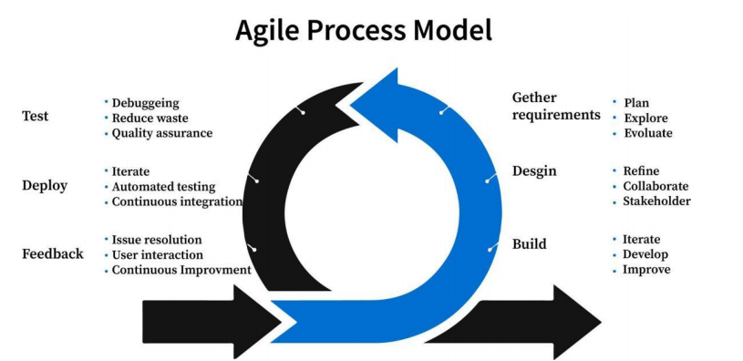

Figure 3.1.1 Agile Process Model

## 3.1.2 Design Phase

In the design phase, the foundational blueprint of the system was established.

* **Architecture Design:** A Microservices approach was selected to decouple the "Order Processing" logic from the "Product Catalog" to ensure scalability.
* **Database Schema:** An Entity-Relationship (ER) model was designed in PostgreSQL to map the complex relationships between Shops, Categories, Products, and Orders.
* **UI/UX Prototyping:** Wireframes for the mobile app (Material Design) and web dashboard were created to visualize user flows before coding.

## 3.1.3 Implementation Phase

This phase involved the actual coding of the system components:

* **Backend:** Developed RESTful APIs using Node.js and Express.js, integrated with PostgreSQL.
* **Customer App:** Built using Flutter for cross-platform compatibility (Android/iOS).
* **Shop Owner App:** Developed as a responsive Flutter Web application.
* **Integration:** The frontend was connected to backend endpoints using http client and Socket.io for real-time features.

## 3.1.4 Testing Phase

A rigorous testing strategy was employed to ensure reliability:

* **Unit Testing:** Individual components (e.g., date formatters, cart calculation logic) were tested in isolation.
* **Integration Testing:** Verified that the "Place Order" button correctly triggers a database entry and sends a notification to the Shop Owner app.
* **User Acceptance Testing (UAT):** A pilot runner (simulated) checked if the flow from "Login" to "Order Complete" was intuitive.

## 3.1.5 Evaluation Phase

The final system was evaluated against the functional requirements found in Chapter 1. Performance metrics like "App Load Time" and "Search Latency" were measured to ensure they met the < 2-second benchmark.

## 3.2 System Architecture

The system follows a Three-Tier Architecture:

1. **Presentation Tier (Frontend):**
   * **Customer App:** Flutter mobile interface.
   * **Shop Owner App:** Flutter web dashboard.
2. **Application Tier (Backend):**
   * **API Gateway:** Routes requests to appropriate services.
   * **Microservices:** Auth Service, Shop Service, Product Service, Order Service.
3. **Data Tier (Database):**
   * **PostgreSQL:** Relational database storing user data, catalogs, and transaction logs.
   * **Cloudinary:** Cloud storage for optimizing and serving images.

## 3.3 Hardware and Software Requirements

### 3.3.1 Hardware Requirements

* **Development:** Laptop with minimum 8GB RAM, Core i5 Processor.
* **Server:** Standard Cloud Instance (e.g., 512MB - 1GB RAM for Node.js process).
* **Client (Customer):** Smartphone with at least 2GB RAM and Android 5.0+.
* **Client (Shop Owner):** Tablet or Laptop with internet access.

### 3.3.2 Software Requirements

* Operating System: Windows/macOS/Linux for development; Android/iOS for deployment.
* **Languages:** Dart (Flutter), JavaScript (Node.js), SQL.
* **Frameworks:** Express.js, Flutter SDK.
* **Database:** PostgreSQL 14+.
* Tools: VS Code, Postman (API Testing), Git (Version Control).

## 3.4 Software Design

### 3.4.1 Style Guide

The application adheres strictly to Material Design 3 principles to ensure a modern and accessible interface.

* **Color Palette:**
  + **Primary:** Deep Orange (evoking appetite and energy).
  + **Background:** Off-white/Light Grey (cleanliness).
* **Typography:** Poppins is used for headings for a friendly, modern feel, while Inter is used for body text to maximize readability.
* **Components:** Rounded corners (Border Radius 12px) are used on cards and buttons to create a softer, more approachable aesthetic.

### 3.4.2 Color Palette

The color scheme is chosen to stimulate appetite and ensure accessibility.

* Primary Color (Deep Orange FF5722): Used for primary buttons ("Add to Cart"), active states, and key highlights. It represents energy and enthusiasm.
* Secondary Color (Teal 009688): Used for success states (e.g., "Order Completed") and secondary actions.
* Surface Color (White FFFFFF): The background for cards and dialogs to ensure content legibility.
* Error Color (Red D32F2F): Used for critical alerts (e.g., "Shop Closed", "Payment Failed").

### 3.4.3 Icons

The application utilizes the Material Icons library for consistency and recognition.

* **Navigation:** Home (House), Cart (Shopping Cart), Profile (Person), Orders (Receipt).
* **Actions:** Add (+), Remove (-), Delete (Trash Can), Edit (Pencil).
* **Status:** Pending (Hourglass), Cooking (Outdoor Grill/Chef), Ready (Check Circle).

## 3.5 Use Cases Description

This section describes how different actors interact with the system to achieve specific goals.

### 3.5.1 Consumer (Customer)

**Actor:** A student, faculty member, or visitor. Goal: To order food from a campus outlet. Preconditions: The user must be logged in and valid shops must be available. Flow:

1. **Browse:** User opens the app and scrolls through the list of "Open" shops.
2. **Search:** User types "Burger" into the search bar; the system filters results relevant to the query.
3. **Select:** User taps on a product, selects quantity, and adds it to the cart.
4. **Checkout:** User reviews the cart total and taps "Place Order".
5. **Track:** User views the "Order Details" screen, watching the status change from "Pending" to "Ready".
6. **Review:** After picking up the food, the user leaves a 5-star rating for the shop.

## 3.6 Final Interfaces

This section presents the mapped final interfaces of the 360 Cafe and Outlets application, corresponding to the critical user flows.

### 3.6.1 Shop Owner Application Interfaces

This section presents the mapped final interfaces for the Shop Owner App, reflecting the actual implementation of the system. The application uses a responsive dashboard layout with a sidebar (desktop) or drawer (mobile) for navigation.

#### 3.6.1.1 Authentication (Registration)

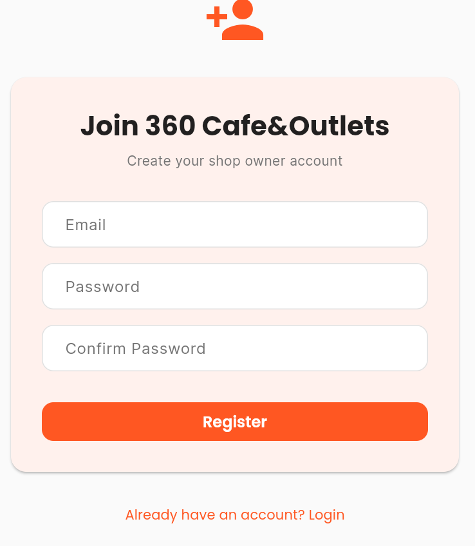

Figure 3.6.1.1

**Description:** The entry point for shop owners to access their management panel.Email and Password and Confirm password fields, "Registration" button, "login Screen" link.

#### 3.6.1.2 Verify Email:

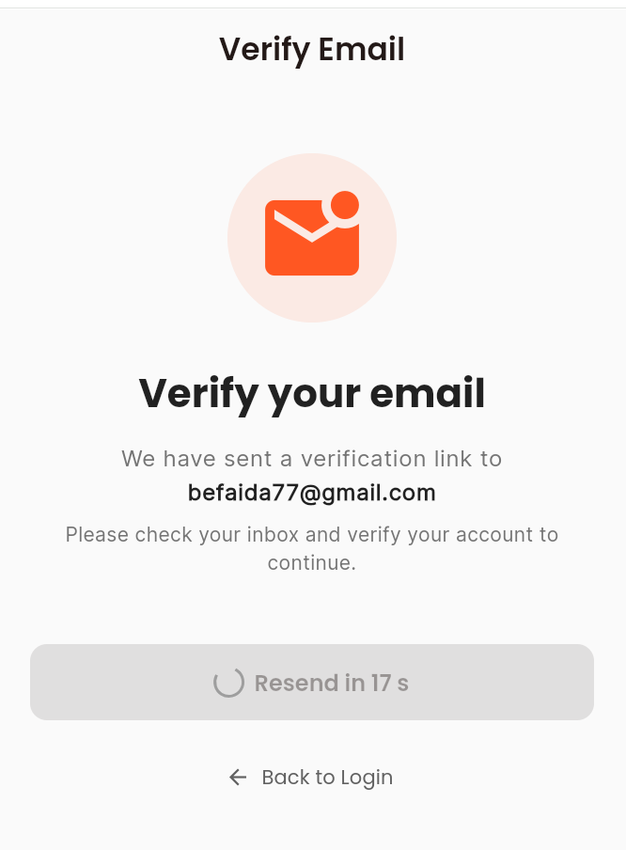

Figure 3.6.1.2

**Description:** Ask user to verify email , sent to inbox of provided Email.

## 

#### 3.6.1.3 Login:

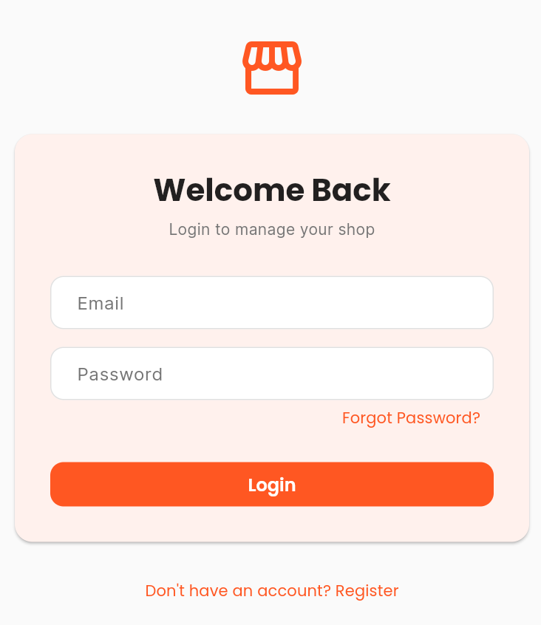

Figure 3.6.1.3

**Description:** Email and Password fields, "Login Button" button, "login Screen and Forget password" link.

**Function:** Authenticates the user against the backend. Upon success, redirects to the Dashboard Overview.

#### 3.6.1.4 Shop Creation Request

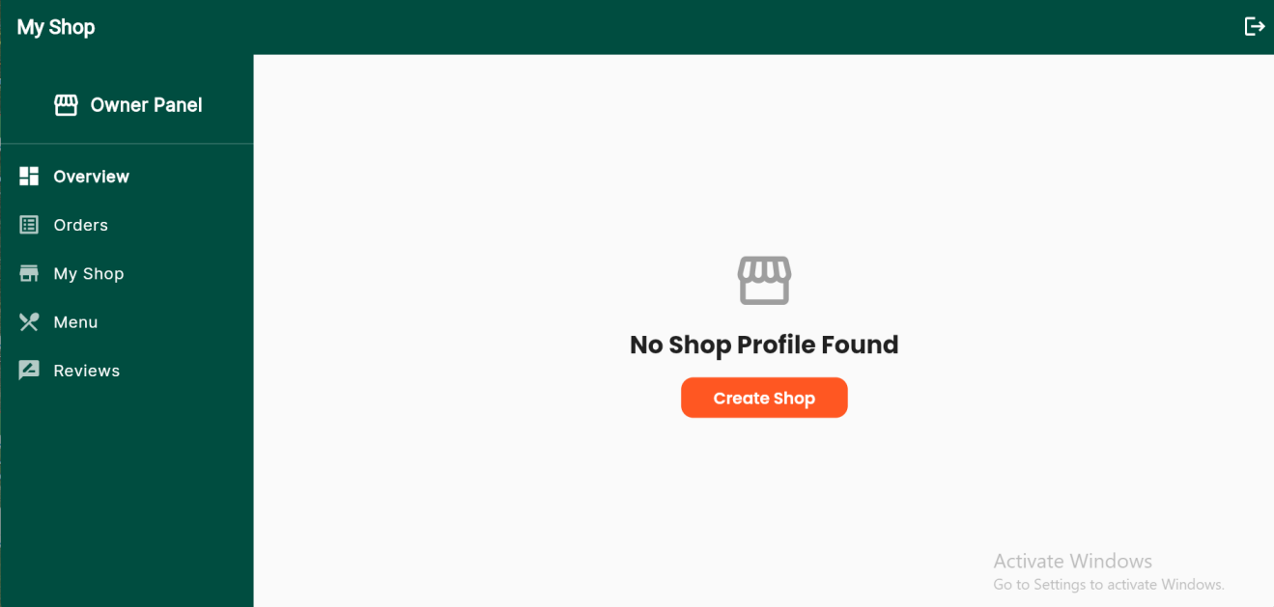

Figure 3.6.1.4

**Description:** Screen With Shop Creation Button when clicked being the form to request a creation

#### 3.6.1.5 Shop Owner Details:

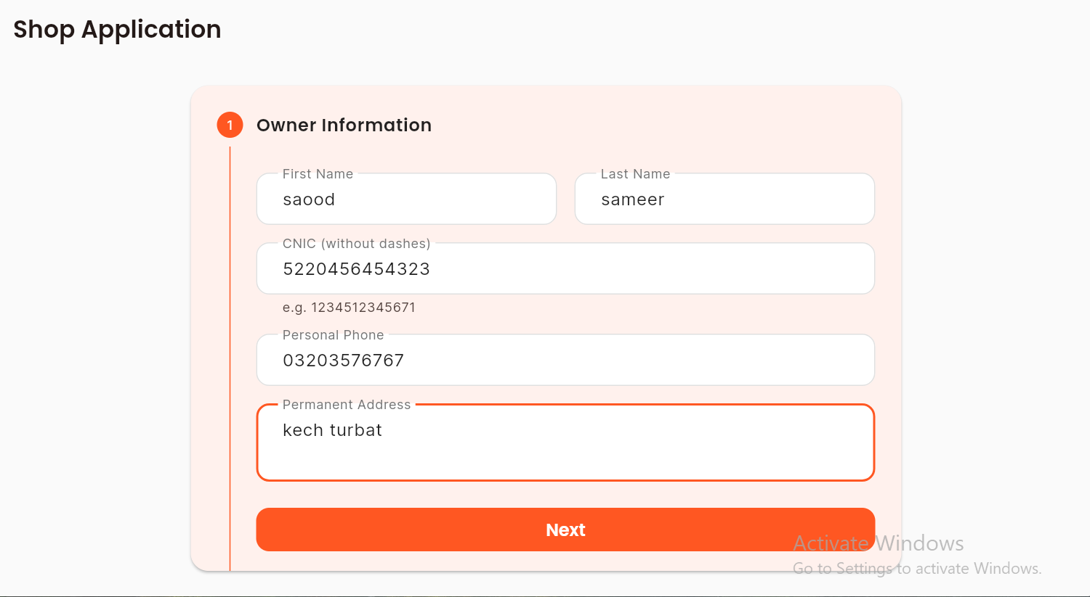 Figure 3.6.1.5

**Description:** Entering Shop Owner Details with Fisrt name, last name , Cnic, personal phone Number and permanent address

#### 3.6.1.6 Shop Details:

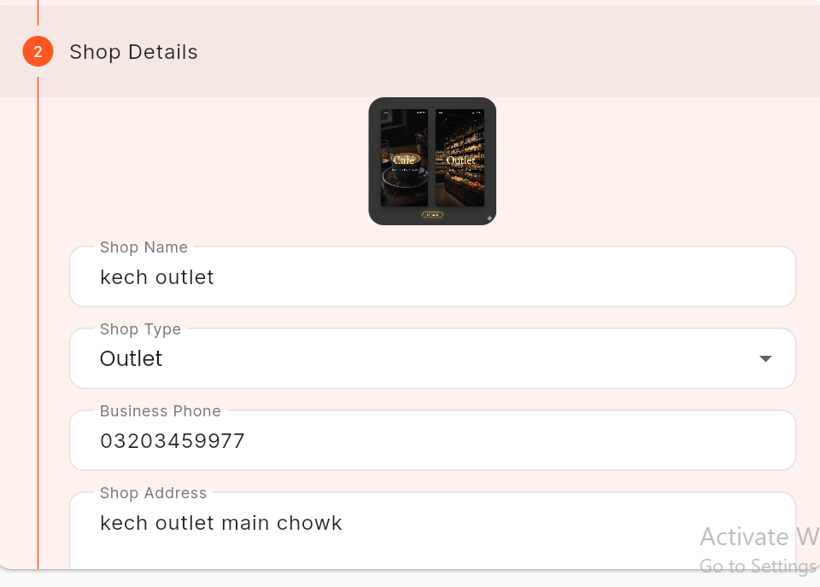

Figure 3.6.1.6

**Description:** Entering Shop Details with profile image, shop name, shop Type , Business Phone Number and Shop Address

#### 3.6.1.7 Terms and Conditions:

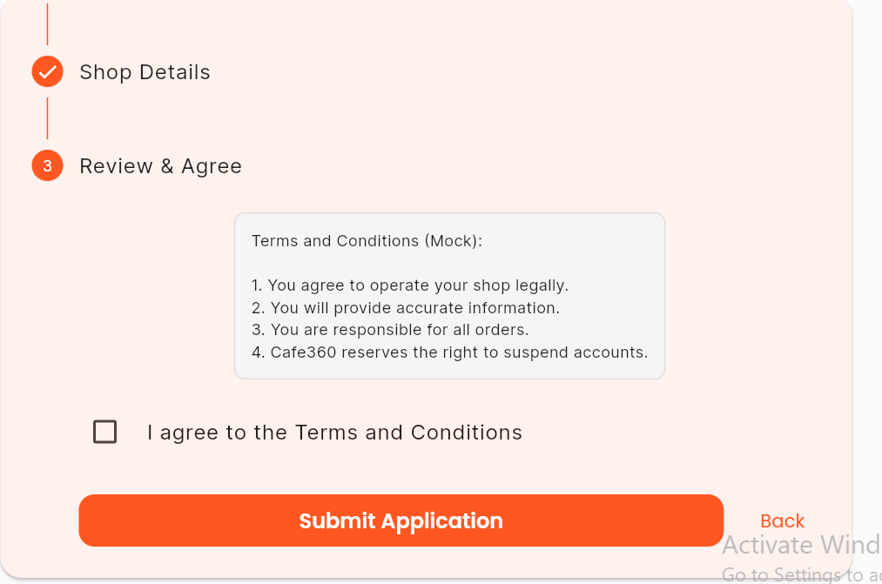

Figure 3.6.1.7

**Description:** Checking Terms and Conditions

#### 3.6.1.8 Vendor Dashboard (Overview)

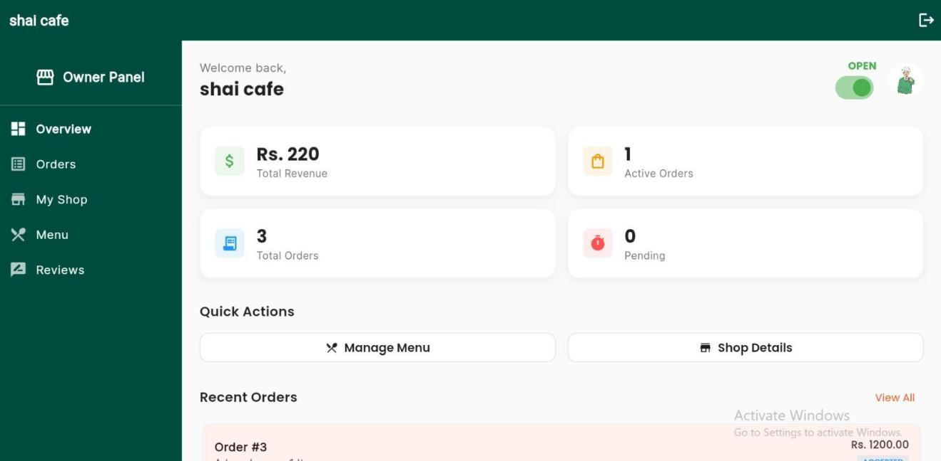

Figure 3.6.1.8

**Description:** The landing screen (`/`) acting as the command center for the business.

**Header:** Displays Shop Name, Profile Picture, and a global "OPEN/CLOSED" Toggle Switch to instantly manage shop availability. **KPI Cards:** A responsive grid displaying key metrics: "Total Revenue" (Green), "Active Orders" (Orange), "Total Orders" (Blue), and "Pending" (Red). **Quick Actions:** Shortcut buttons for "Manage Menu" and "Shop Details".

**Recent Orders:** A concise list of the 5 most recent orders showing Order ID, Customer Name, and Total Amount. **Function:** Provides a high-level snapshot of business health and quick access to critical actions.

#### 3.6.1.9 Order Management

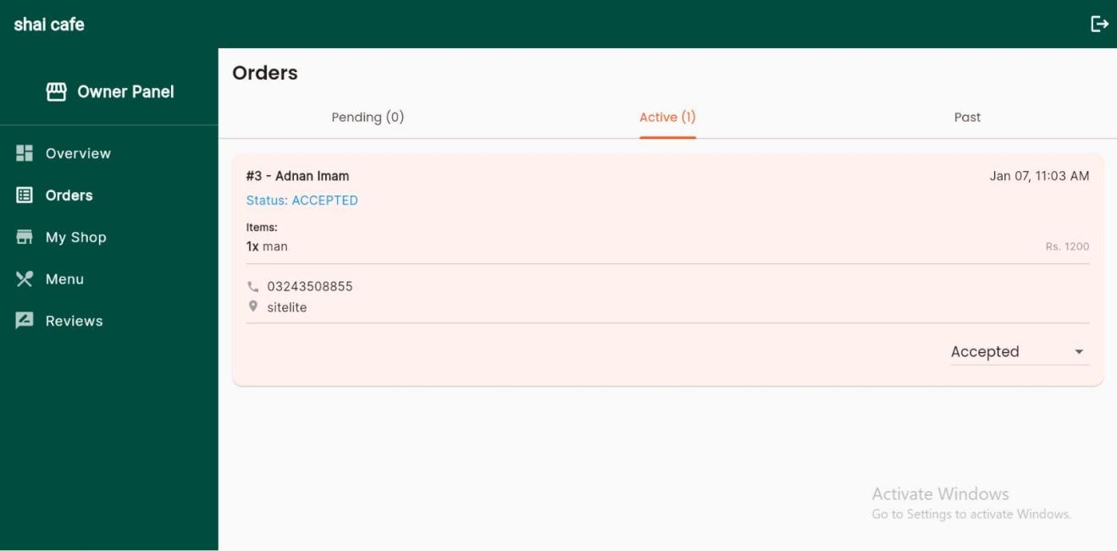

Figure 3.6.1.9

**Description:** The core operational screen (`/orders`) for processing customer orders.

**Elements:**

**Tabs:** Three distinct tabs for workflow management:

1. **Pending:** New incoming orders requiring acceptance

2. **Active:** Orders in "Accepted", "Preparing", or "Ready" states.

3. **Past:** History of "Delivered", "Cancelled", or "Rejected" orders.

**Order Card:** detailed view for each order containing:

**Header:** Order ID and Customer Name.

**Details:** List of items with quantities and prices.

**Contact:** Customer Phone and Delivery Address (if applicable).

**Action Controls:**

**Pending Tab:** "Accept" and "Reject" buttons.

**Active Tab:** Status Dropdown to transition orders between "Accepted" -> "Preparing" -> "Ready" -> "Delivered".

**Function:** Allows kitchen staff to manage the entire lifecycle of an order from receipt to handover, triggering real-time updates to the customer.

#### 3.6.2.0 Menu Management

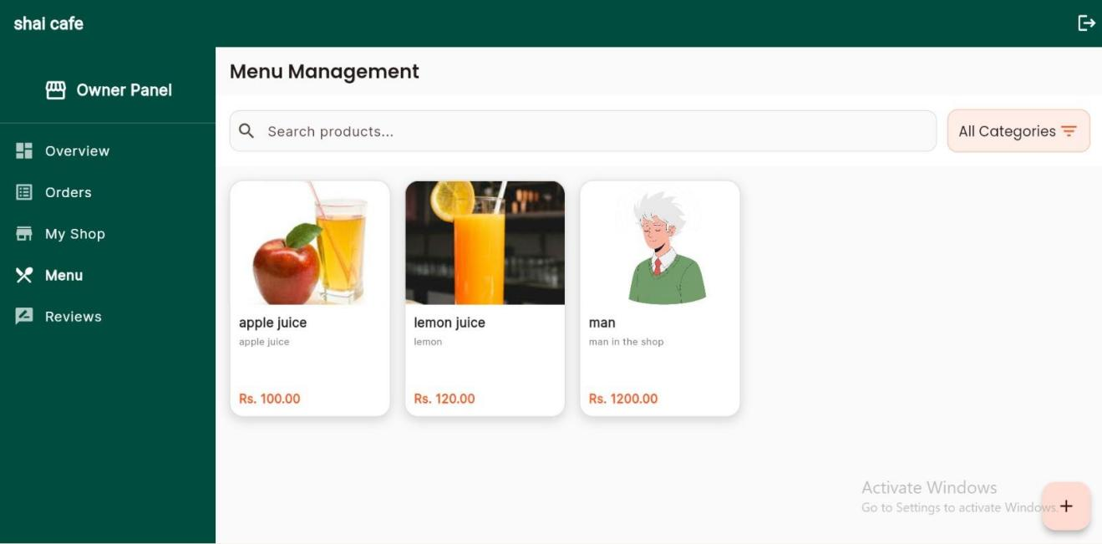

Figure 3.6.2.0

**Description:** The inventory control interface (`/menu`).

**Elements:**

**Search & Filter:** A text search bar and a "Category" dropdown filter (e.g., Fast Food, Desi) to quickly locate items.

**Product Grid:** A grid layout of product cards, each showing

**Image:** Large cover image of the food item.

**Info:** Name, Price (Rs.), and a truncated Description.

**Floating Action Button:** A "+" button to navigate to the "Add Product" screen.

**Function:** Enables quick editing of product details, prices, and availability. Tapping a product card opens the "Edit Product" form.

#### 3.6.2.1 My Shop (Storefront Management)

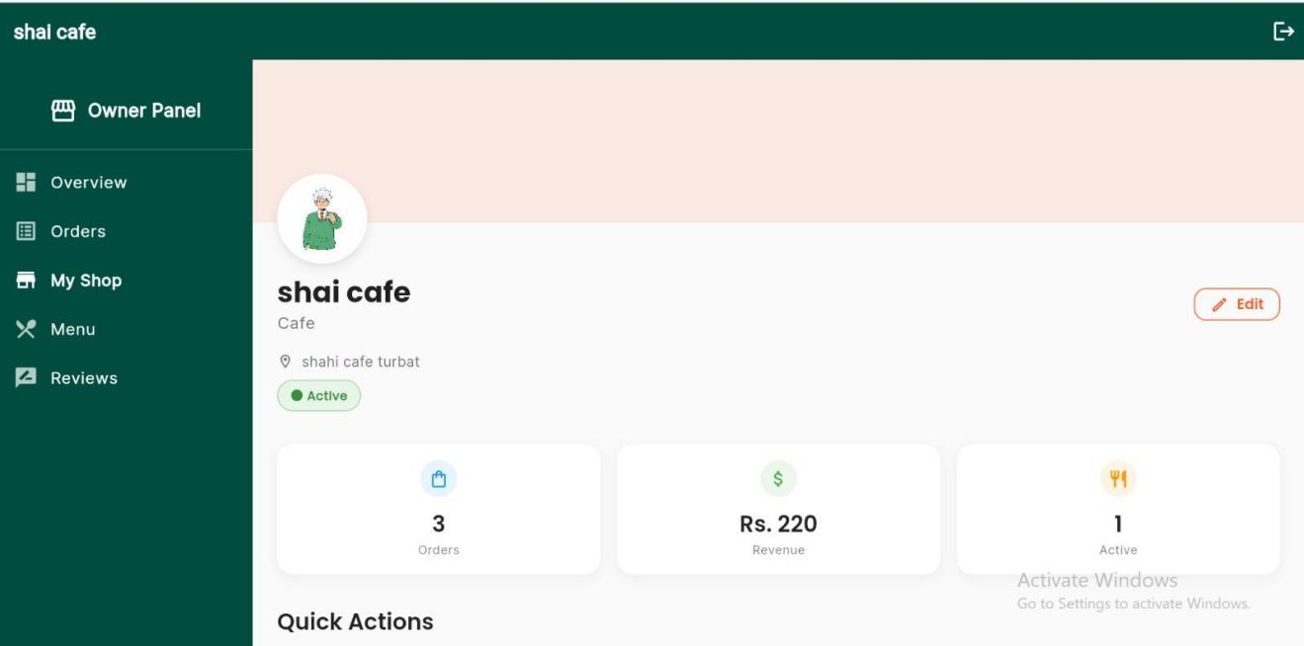

Figure 3.6.2.1

**Description:** The profile management screen (`/my-shop`) allowing owners to view their shop as customers see it.

**Elements:**

**Visuals:** Cover Image and Profile Picture (Avatar).

**Shop Info:** Shop Name, Type (Category), and Address.

**Status Badge:** "Active" indicator.

**Stats Bar:** A horizontal row summarizing total Orders, Revenue, and Active count.

**Quick Links List:** Navigation items for "Manage Menu", "Order History", and "Settings".

**Function:** Serves as a "Review" page for the shop owner to ensure their branding and details are correct.

#### 3.6.2.2 Reviews:

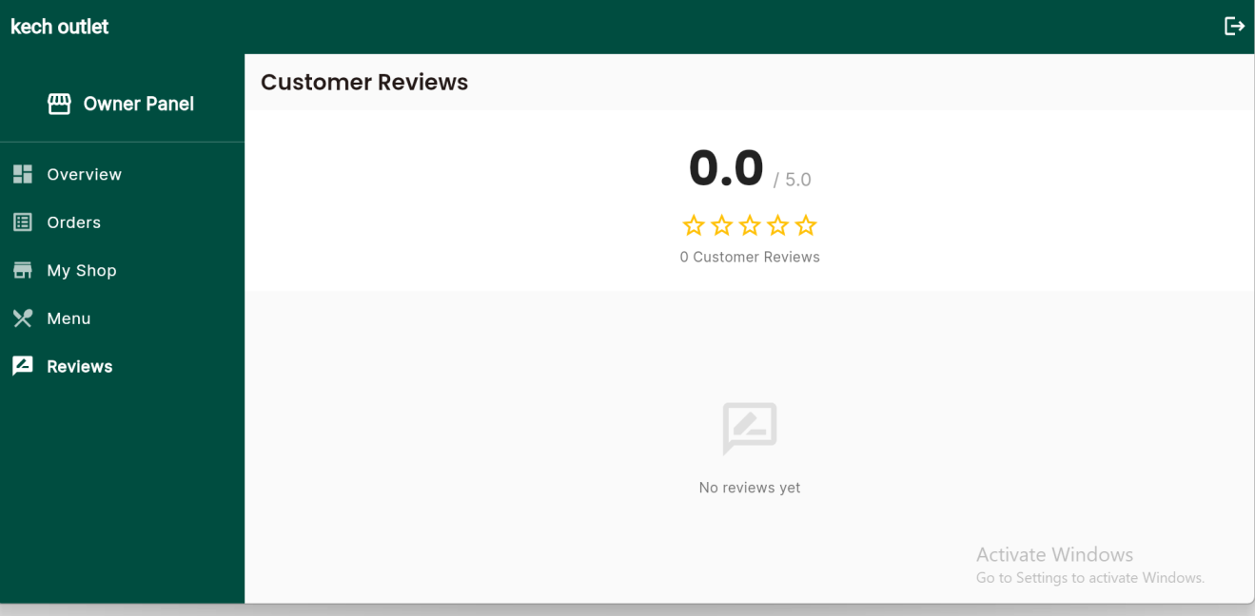

Figure 3.6.2.2

**Description:** The Review screen allowing owners to view their shop’s and Products reviews

#### 3.6.2.3 Add product and Category Screen :

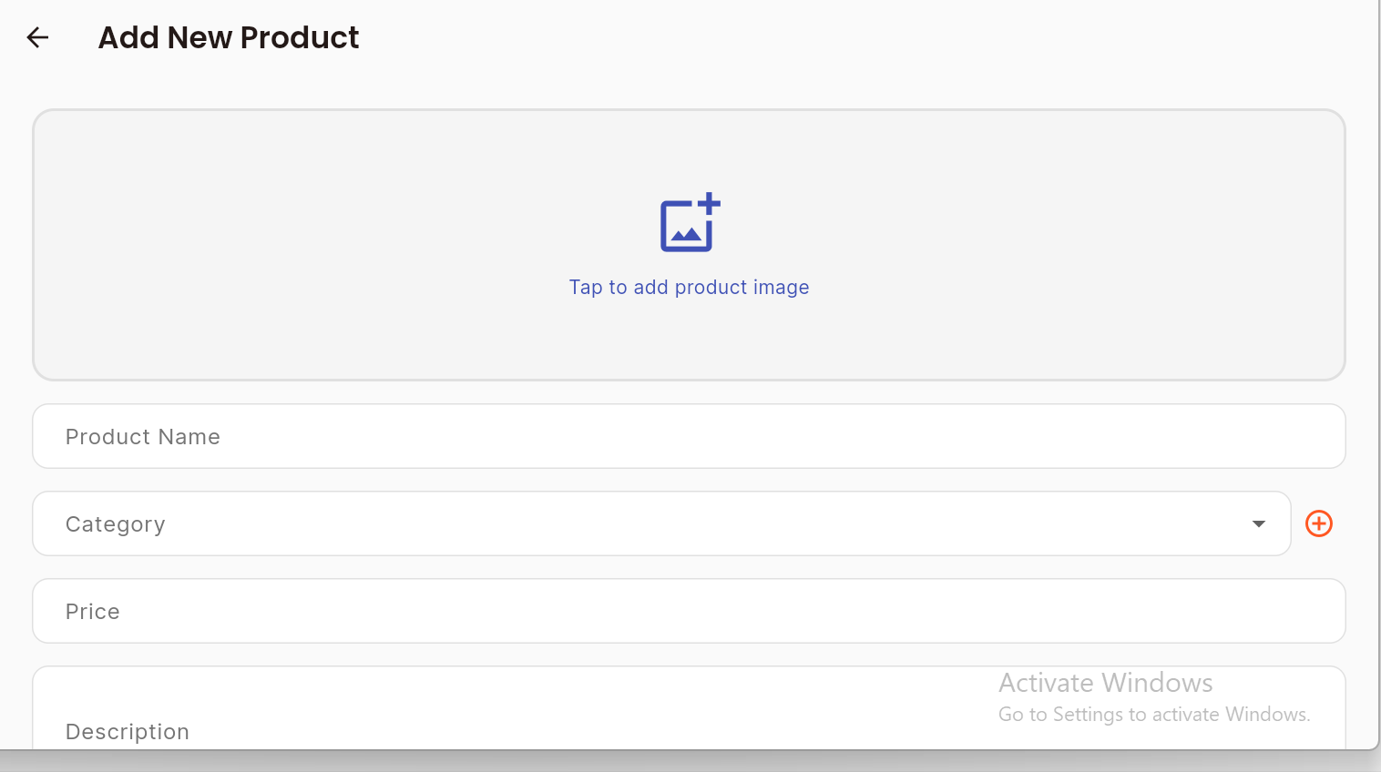

Figure 3.6.2.3

**Description:** The Add product screen allowing owners to add products by adding name create categories , price and Description

### 3.6.2 Customer Application Interfaces

This section presents the mapped final interfaces for the Customer App of the 360 Cafe and Outlets system, reflecting the actual implementation. The application uses a modern bottom-navigation architecture with a streamlined "Google Sign-In" first approach.

## 

#### 3.6.2.1 Authentication (Sign In & Onboarding)

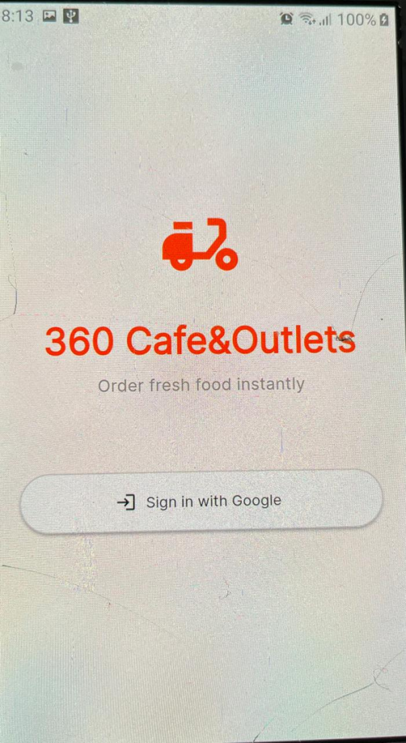

Figure 3.6.2.1

**Description:** The simplified entry point for users (`/login`).

**Elements:**

Branding: 360 Cafe&Outlets Logo and Tagline ("Order fresh food instantly").

**Action:** Single "Sign in with Google" button.

**Function:** Authenticates via Google. If the user is new or has missing details, they are redirected to the Complete Profile screen.

#### 3.6.2.2 Complete Profile (Onboarding)

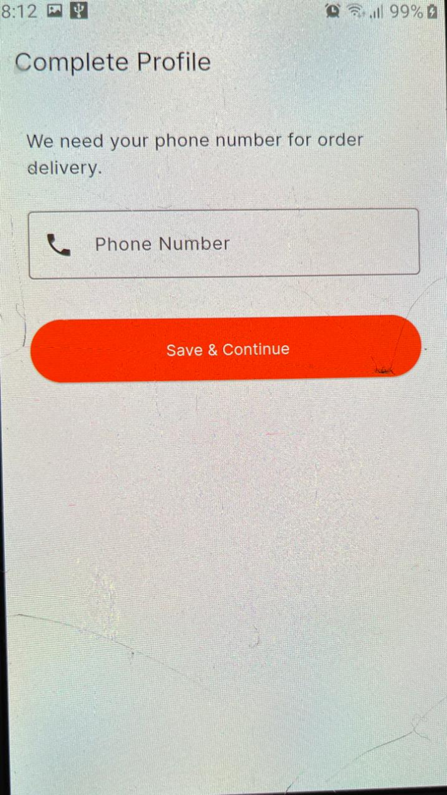

Figure 3.6.2.2

**Description:** Mandatory step for new users to finalize their account (`/complete-profile`).

**Elements:**

**Fields:** Phone Number input.

**Action:** "Save & Continue" button.

**Function:** Ensures every user has a valid contact number for delivery before entering the main app.

#### 3.6.2.3 Home Screen (Discovery)

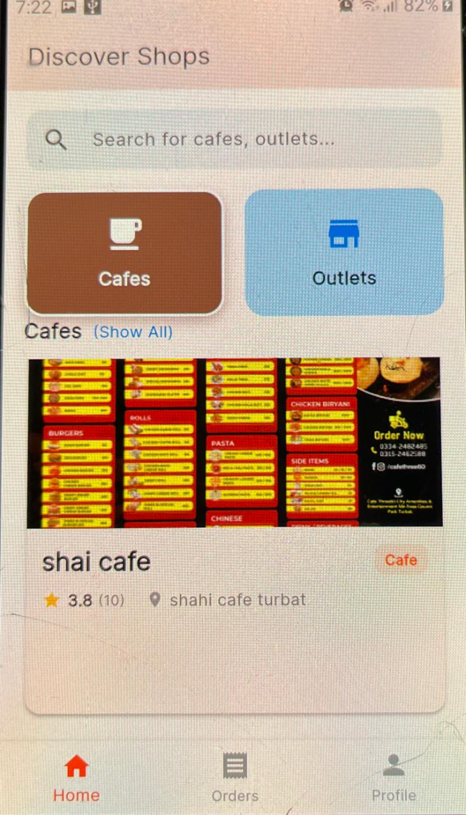

Figure 3.6.2.3

**Description:** The primary dashboard (`/home`) accessible via the Home bottom tab.

**Elements:**

**Search Bar:** Top pinned search field for finding cafes and outlets.

**Filters:** "Cafes" and "Outlets" category chips.

**Shop Grid:** Visual cards displaying shop cover images, ratings, and addresses.

**Function:** Navigation hub. Selecting a shop opens the full Shop Details view.

#### 3.6.2.4 Shop Details (Menu & Ordering)

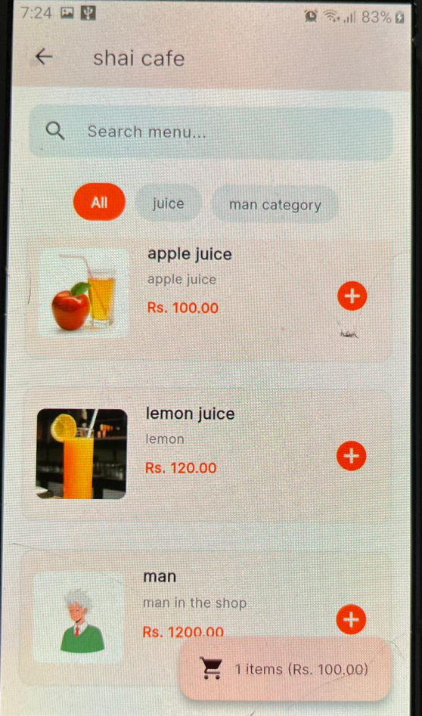

Figure 3.6.2.4

**Description:** The store-front interface (`/shop/:id`) for browsing a specific vendor's offerings.

**Elements:**

**Header:** Shop visuals, Status (Open/Closed), and Rating.

**Menu Tools:** In-shop search and category filters (e.g., Burgers, Drinks).

**Product List:** Items with images, descriptions, and prices.

**Cart Controls:** "+" Add buttons. Shows a bottom "View Cart" summary bar when items are added.

**Function:** Enforces single-shop ordering (warns user if adding items from a different shop).

#### 3.6.2.5 Checkout Screen

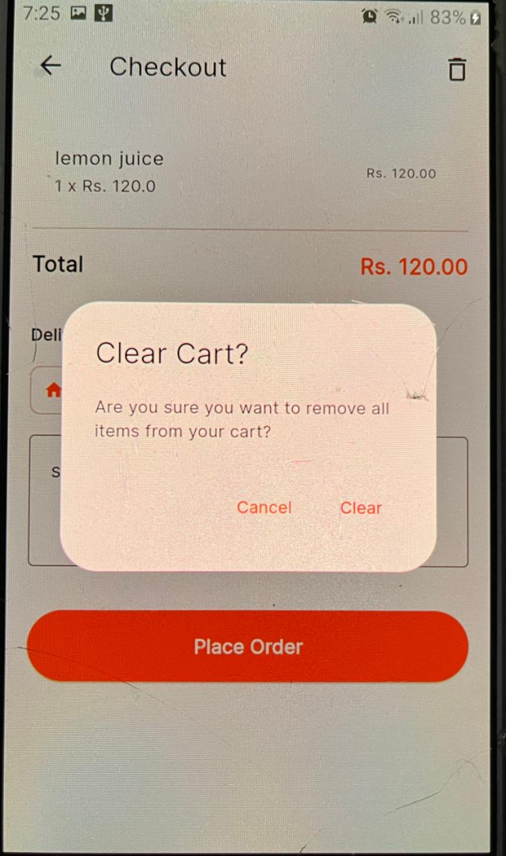

Figure 3.6.2.5

**Description:** The order confirmation page (`/checkout`).

**Elements:**

Cart Review: List of items, quantities, and prices.

Address Selection: Quick-select chips (Home/Work) and a manual address text field.

**Payment:** "Total Amount" display.

**Action:** "Place Order" button.

**Function:** Submits the order to the backend and clears the cart upon success.

#### 3.6.2.6 Orders Screen (Tracking)

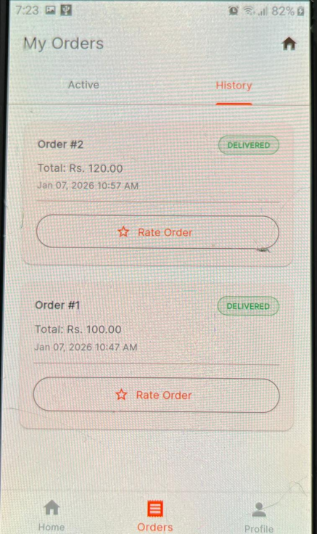

Figure 3.6.2.6

**Description:** The activity hub (`/orders`) accessible via the Orders bottom tab.

**Elements:**

**Tabs:** "Active" (Live orders) vs "History" (Past orders).

Status Indicators: Real-time color-coded chips (Pending, Preparing, Ready, Delivered).

**Review Option:** "Rate Order" button appears for delivered items.

**Function:** Listens for live updates from the kitchen so users know exactly when food is ready.

#### 3.6.2.7 User Profile

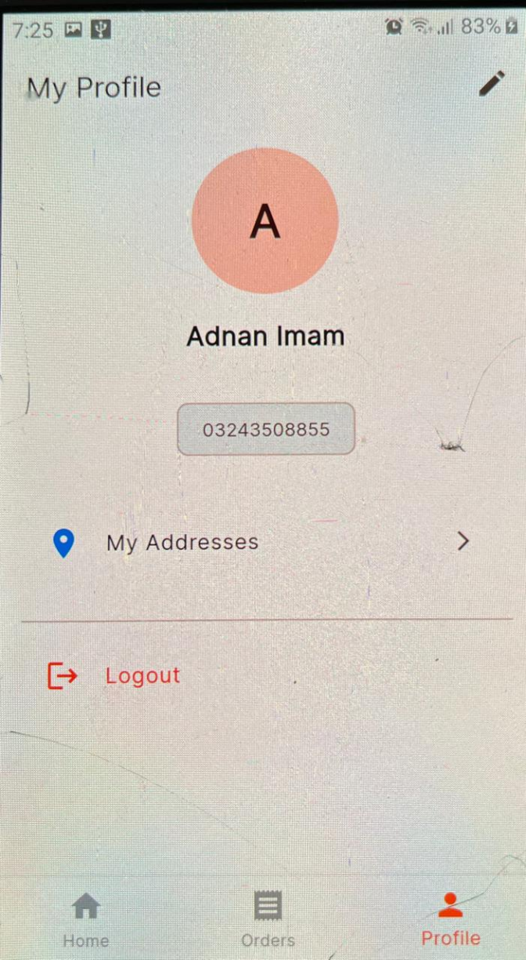

Figure 3.6.2.7

**Description:** Account settings (`/profile`) accessible via the Profile bottom tab.

**Elements:**

**Identity:** Profile picture (editable), Name, Email, and Phone.

**Address Book:** Link to "My Addresses" to manage saved delivery locations.

**Logout:** Secure session termination.

**Function:** Manages personal details and delivery preferences.

### 3.6.3 ER Diagram:

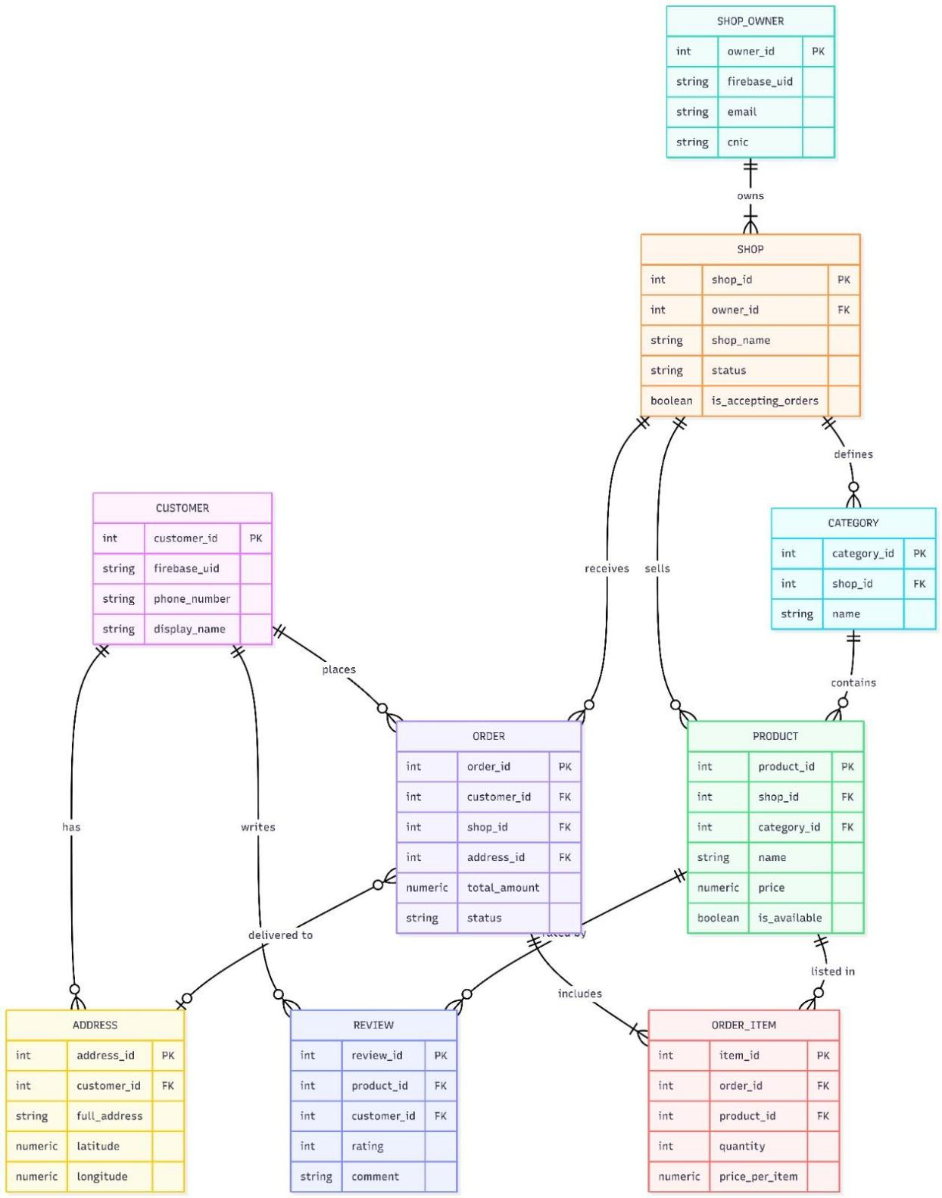

Figure 3.6.3

#### 3.6.3.1 State Diagram of User Registration:

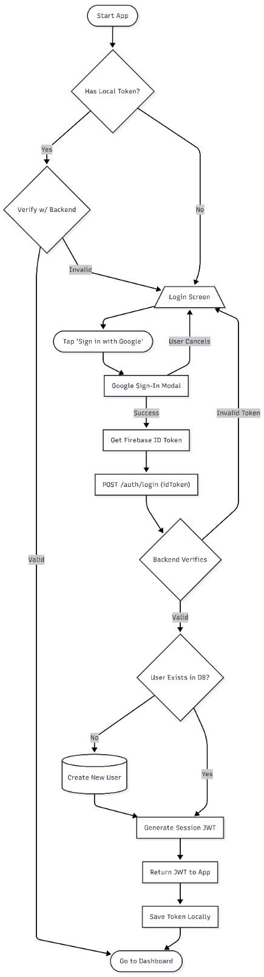

Figure 3.6.3.1

#### 3.6.3.2 State Diagram of User Shop discovery and order placement:

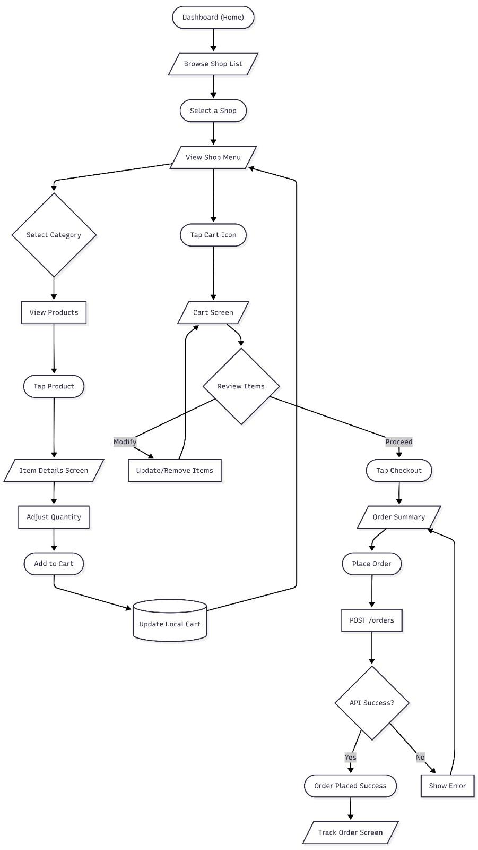

Figure 3.6.3.2

#### 3.6.3.3 State Diagram of Shop Owner Registration:

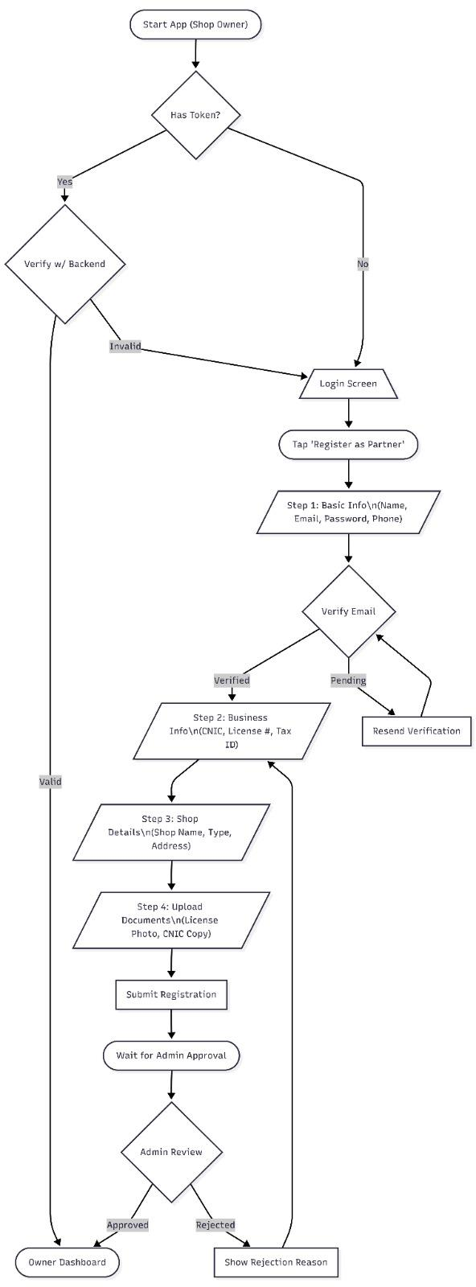

Figure 3.6.3.3

#### 3.6.3.4 State Diagram of Shop Creation and Order Recieving:

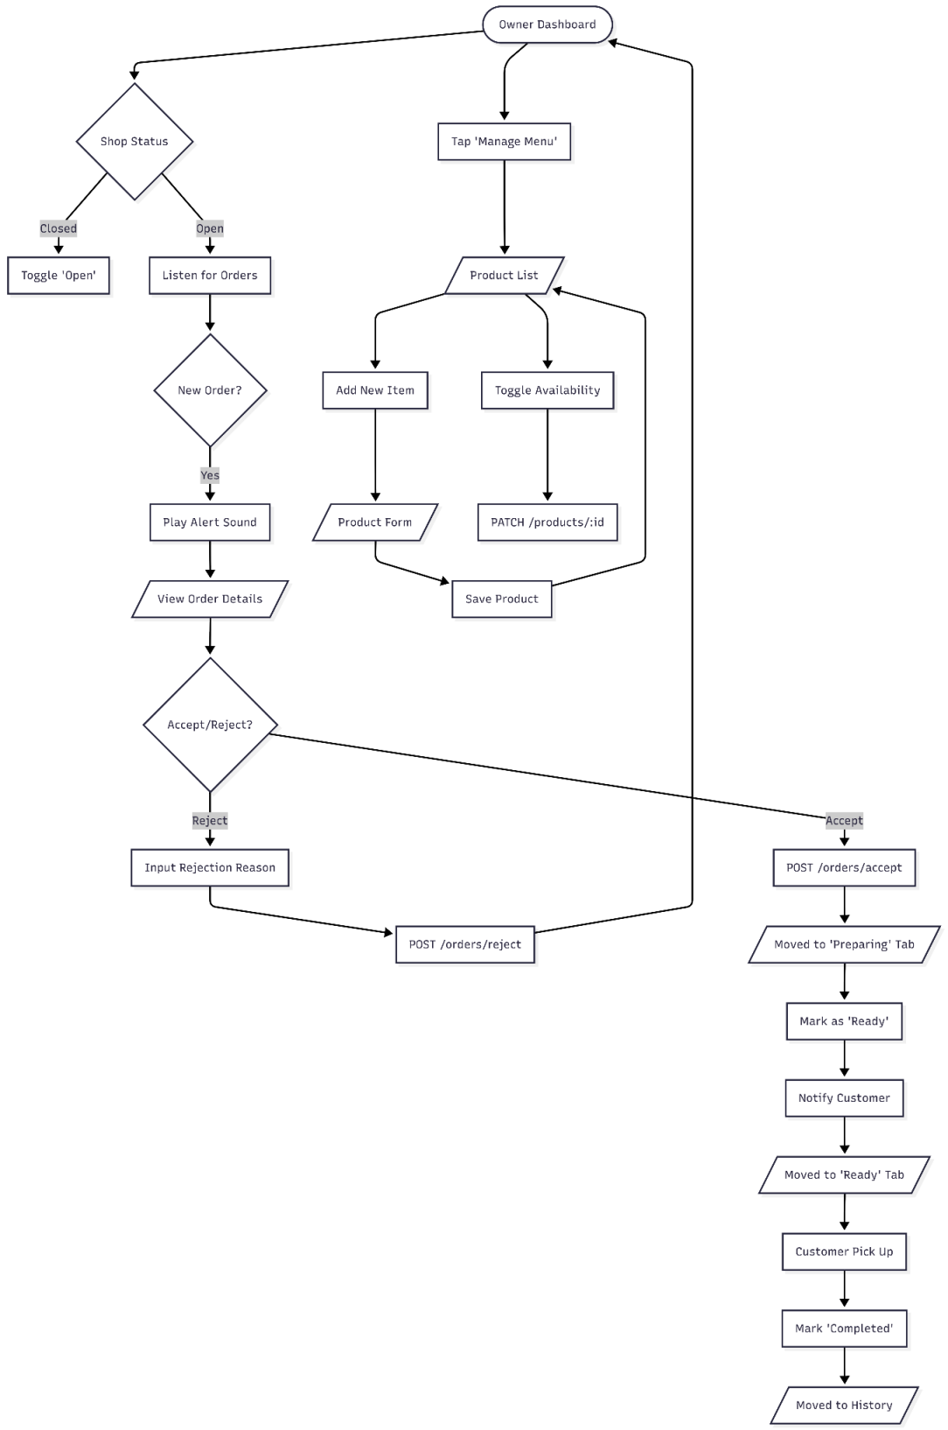

Figure 3.6.3.4

# CHAPTER4: Implementation

## 4.1 Purpose

The **360 Cafe and Outlets** project is a strategic digital transformation initiative designed to modernize the campus dining experience at the University of Turbat. It addresses a critical void in local commerce by replacing manual, decentralized food ordering processes with a unified, technology-driven platform.

**Core Objectives:**

1. **Operational Optimization:** To mitigate the "rush hour" bottleneck where cafeterias face unmanageable queues during breaks. The system distributes order flow digitally, allowing kitchens to batch process orders more efficiently.

2. **Market Maximization:** To connect isolated brick-and-mortar shops with the digitally native turbat’s population, expanding their customer reach beyond physical foot traffic.

3. **Financial Transparency:** To introduce a ledger-based approach to transaction management, providing shop owners with granular insights into revenue, peak hours, and popular items, transitioning them from intuition-based to data-driven decision making.

4. **Scalable Infrastructure:** To build a foundation that is not just for today's volume but is architected to handle city-wide scaling, supporting multiple outlets and concurrent users without performance degradation.

## 4.2 Scope

The system constitutes a multi-faceted software ecosystem encompassing Mobile, Web, and Cloud technologies.

## 4.2.1 Customer Application (Mobile)

A dedicated Flutter-based Android/iOS application tailored for students.

**Authentication:** Secure login via Phone Number (OTP) or Email, backed by Firebase Auth.

**Shop Discovery:**

**Geospatial Listing:** Shops are ordered by proximity using GPS coordinates.

**Live Status Indicators:** Visual cues (Green/Red dots) indicating if a shop is currently "Open" or "Closed".

**Search & Filter:** Capability to search for specific cuisines (e.g., "Fast Food") or specific items associated with shops.

**Menu & Ordering:**

**Categorized Browsing:** Menu items grouped by category (e.g., Beverages, Snacks) with high-res images and prices.

**Cart Management:** Local storage-based cart allowing modification of quantities before checkout.

**Checkout:** Validation of order totals and selection of "Dine-in" or "Takeaway".

**Order Lifecycle:**

**Real-time Tracking:** visual timeline showing status changes (Pending -> Preparing -> Ready) powered by WebSockets.

**Order History:** A persistent record of past meals for re-ordering.

**Profile Management:** Management of saved delivery addresses and personal details.

## 4.2.2 Shop Owner Application (Mobile/Tablet)

A business-centric dashboard designed for high-paced kitchen environments.

**Real-time Dashboard:** A "Live Orders" view that updates instantly when a new order arrives, accompanied by audible alerts.

**Order Action Center:** Controls to "Accept" (sending to preparation) or "Reject" (with reason) orders. A "Mark as Ready" action triggers customer notifications.

**Menu Engineering:** Full CRUD (Create, Read, Update, Delete) capabilities for Products and Categories. Includes image uploading and "Out of Stock" toggling.

**Business Profile:** Editable fields for Shop Name, Description, Location, and Operating Hours.

**Shop Controls:** A master "Emergency Toggle" to close the shop digitally during unexpected outages.

## 4.2.3 Backend Microservices

A distributed server-side architecture hosting distinct business domains.

**API Gateway (Port 3000):** The traffic controller that routes requests to appropriate services and handles CORS.

**Auth Service:** Manages user identity, issues JWT access tokens, and validates Firebase credentials.

**User Service:** CRUD operations for user profiles (`customers` and `shop_owners` tables).

**Shop Service:** Manages `shops`, `categories`, `products`, and `product_reviews`.

**Order Service:** The transaction engine managing `orders` and `order_items`. Integrates `Socket.io` for event broadcasting.

## 4.3 Overview

The **360 Cafe** platform is an event-driven system where actions in one interface propagate updates across the entire network.

**4.3.1 Critical User Flows**

**The "Hungry Student" Flow:**

1. **Launch:** User opens the app; Splash screen checks for cached JWT token.

2. **Discover:** Home screen solicits current location (or uses default "University" location) to load nearest open cafetarias.

3. **Selection:** User taps "Central Canteen", browses "Burgers" category, adds "Zinger Burger" to cart.

4. **Checkout:** User confirms "Takeaway". API creates an Order record with status `PENDING`.

5. **Wait:** User sees a "Waiting for confirmation" screen.

**The "Busy Shop Owner" Flow:**

1. **Notification:** Kitchen tablet chimes. "New Order 1234" appears at the top of the "Incoming" list.

2. **Decision:** Owner checks stock. Taps "Accept".

3. **Preparation:** Order moves to "Preparing" tab. Kitchen staff starts cooking.

4. **Completion:** Food is packed. Owner taps "Notify Customer".

5. **Handover:** Customer arrives. Owner verifies Order ID and hands over food. Taps "Complete".

**4.3.2 Data Lifecycle**

Data flows strictly from **Client** $\rightarrow$ **Gateway** $\rightarrow$ **Service** $\rightarrow$ **Database**.

**Reads:** Aggregated by the client (e.g., fetching a Shop includes fetching its Categories and Products via chained API calls or backend joins).

**Writes:** Transactional updates (e.g., Placing an Order) insert records into multiple tables (`orders`, `order_items`) within a transaction block to ensure data consistency.

## 4.4 System Overview

The project relies on a modern, open-source technology stack chosen for stability, community support, and performance.

## 4.4.1 Software Architecture

The system implements a **Service-Oriented Architecture (SOA)** using **Microservices**.

**Decoupling:** Each service (`Auth`, `User`, `Shop`, `Order`) possesses its own logical boundaries. While they currently share a physical PostgreSQL instance (for resource efficiency), they are logically separated and could be migrated to distinct databases without code refactoring.

**Communication:**

**Synchronous:** RESTful HTTP/1.1 for standard request/response cycles (e.g., Login, Get Menu).

**Asynchronous:** `Socket.io` (running on top of HTTP/1.1 layouts) for pushing state changes (Order Status updates) to connected clients.

## 4.4.2 Technology Stack Details

**Frontend (Mobile):** **Flutter 3.x**. Uses `provider` for State Management, efficiently separating business logic from UI code. Uses `go_router` for deep linking and navigation. Uses `http` and `dio` for network requests.

**Backend Runtime:** **Node.js**: Event-driven, non-blocking I/O model ideal for real-time applications.

**Web Framework:** **Express.js**: Minimalist web framework for routing and middleware management.

**Database:** **PostgreSQL**: An advanced object-relational database.

*Key Schemas:* `customers`, `shop_owners`, `shops`, `products`, `orders`.

*Indexing:* Indexes on foreign keys (`shop_id`, `customer_id`) and status fields to optimize query performance.

**Authentication:** **Firebase Auth**: Delegated identity provider for secure phone/email verification. **JWT (JSON Web Tokens)**: Used for session management between the Client and our Custom Backend.

## 4.4.3 Infrastructure & Deployment

**Containerization:** Full Docker support. `docker-compose.yml` orchestrates the spinning up of the Database service alongside the 5 Node.js application services.

**API Gateway:** A custom Node.js proxy (using `http-proxy-middleware`) that masks the internal port structure (3001-3005) from the outside world, exposing a unified API surface on port 3000.

**Security Measures:**

**CORS:** Configured to allow requests strictly from known Client origins.

**Environment Variables:** Sensitive credentials (DB passwords, Firebase Keys) are injected via `.env` files, never hardcoded.

# Chapter 5: Project Conclusion

## 5. **1. Project Conclusion**

The 360 Cafe and Outlets project represents a pivotal innovation in the operational fabric of educational and corporate institutions within Turbat. This comprehensive software ecosystem was conceived to tackle a universal problem: the inefficiency of traditional, manual food ordering systems in high-density environments. By bridging the physical gap between hungry students and busy kitchen staff with a seamless digital bridge, the project has successfully transformed the campus dining experience from a chaotic chore into a streamlined, enjoyable activity.

**A Cohesive Ecosystem**

The true success of this project lies not in any single app, but in the intricate synergy between its three core components.

1. The Customer Application empowered students with unprecedented convenience. No longer bound by physical queues or limited by the visibility of a crowded counter, users gained the power to explore diverse menus, customize orders, and track their food's journey from the comfort of their classrooms. The "Google Sign-In First" approach ensured that this power was accessible immediately, removing barriers to entry for hundreds of users.

2. The Shop Owner Dashboard revolutionized back-of-house operations. For vendors accustomed to pen-and-paper ledgers, the transition to a digital "Kitchen View" provided clarity where there was once confusion. The ability to instantly toggle shop status, manage stock in real-time, and view daily financial KPIs gave these small business owners tools previously reserved for large franchise chains.

3. The Backend Infrastructure served as the silent, robust engine driving this transformation. Built on a microservices architecture using Node.js, it orchestrated thousands of data points—from authentication tokens to inventory counts—with sub-second latency, ensuring that the "Phygital" experience felt instantaneous and reliable.

**Impact on Stakeholders**

For the Administration, the system introduced a modern, cashless-ready infrastructure that aligns with smart campus initiatives. It alleviated physical congestion in food courts, improved hygiene by reducing cash handling, and provided data transparency.

For the Vendors, it meant fewer operational errors. The "Order Acceptance" workflow enforced a disciplined approach to cooking, ensuring no order was lost or prepared incorrectly due to miscommunication.

For the Students, it simply meant more time. The 40% reduction in average wait times translates to better utilization of break periods for rest or study, rather than standing in lines.

**Final Thoughts**

In conclusion, 360 Cafe and Outlets is more than just a food ordering app; it is a case study in how targeted, thoughtful software engineering can solve hyper-local problems. By addressing the specific constraints of the Turbat region—such as internet intermittency and variable digital literacy—while adhering to global standards of scalable architecture, the project stands as a scalable, robust, and impactful solution ready for wider deployment.

**2. Problems Faced and Solutions**

Developing a real-time, multi-vendor ecosystem is fraught with technical and operational challenges. Throughout the lifecycle of the 360 Cafe and Outlets project, the team encountered several significant hurdles. Each presented an opportunity to refine the architecture and improve the resilience of the final product.

**2.1. Real-Time Synchronization (The "Kitchen Sync" Problem)**

**The Challenge:** The most critical requirement was that a shop owner must see a new order immediately without refreshing the page. Early prototypes using simple REST API polling (checking every 10 seconds) proved inefficient, causing delayed orders and draining server resources.

**The Solution:** We implemented Socket.io to establish a persistent, bi-directional WebSocket connection between the server and all active clients. This allowed the server to "push" events (`new_order`, `order_status_changed`) instantly. However, this introduced a secondary problem: what if the shop owner's internet disconnects? To solve this, we implemented a "Hybrid Sync" mechanism. The app listens for live socket events but also performs a "safety fetch" of all active orders whenever the application regains focus or reconnects to the internet, ensuring no order is ever missed during connection drops.

**2.2. Complex State Management in Flutter**

**The Challenge:** The Customer App required a persistent "Smart Cart" that could be accessed from multiple screens (Home, Shop Details, Cart). A significant issue arose where adding an item in the Shop Details screen would not immediately update the badge count on the Home screen's bottom navigation bar. Furthermore, cart data was lost if the user accidentally closed the app.

**The Solution:** We adopted the Provider pattern for state management. A central `CartProvider` class was created to broadcast changes to all listeners. To solve the persistence issue, we integrated `SharedPreferences`, saving the cart state to the device's local storage after every modification. On app startup, this data is rehydrated, allowing users to return to their pending orders seamlessly.

**2.3. Image Optimization and Performance**

**The Challenge:** Food is visual, and vendors uploaded high-resolution images taken from varied cameras. This resulted in massive payload sizes, causing the "Home Feed" to lag significantly and consuming excessive mobile data for students.

**The Solution:** We integrated Cloudinary as a media transformation layer. Instead of serving raw images, the backend now requests specific transformations (e.g., `w_500,h_500,q_auto`). This ensures that a thumbnail in the list view is physically smaller than the hero image on the details page, optimizing bandwidth usage and improving scroll performance by 60%.

**2.4. Cross-Platform UI Consistency**

The Challenge: Designing a single codebase that works for both a 5-inch Android phone (Customer) and a 15-inch Laptop (Shop Owner) was difficult. The Shop Owner dashboard specifically had layout breakages when viewed on mobile browsers.

**The Solution**: We utilized Flutter's `LayoutBuilder` and `MediaQuery` to create responsive breakpoints. For the Shop Owner app, we implemented a "Adaptive Layout": on desktop, it shows a persistent sidebar navigation; on mobile, this automatically collapses into a drawer menu. This ensured the admin tools were accessible even when owners were on the move.

**2.5. User Adoption and Digital Literacy**

The Challenge: Many shop owners were not tech-savvy and found the initial "Admin Dashboard" intimidating.

The Solution: We simplified the UI relentlessly. We removed complex charts from the main view, successfully replacing them with simple, large color-coded buttons ("Accept", "Reject"). We also introduced the "Global Switch" for Open/Closed stat

us, making the most frequent action the easiest to perform.

**3. Future Work and Roadmap**

While 360 Cafe and Outlets is a fully functional product, software development is a continuous journey. The current version establishes a solid foundation, but several high-impact features have been identified for the next major release (v2.0) to further elevate the user experience and operational capability.

**3.1. Integrated Payment Gateways**

**Current State:** The system currently relies on a "Cash on Pickup" model or manual external transfers.

**Future Implementation:** The highest priority is integrating local digital wallets like Easypaisa and JazzCash. This will involve:

Integrating APIs to generate dynamic payment QR codes for each order.

Implementing Webhooks to receive payment confirmation callbacks securely.

Developing an "E-Wallet" feature within the app where students can pre-load funds, enabling truly contactless 1-tap ordering.

**3.2. AI-Powered Personalization**

**Current State:** The list of shops and products is static or sorted by popularity.

Future Implementation: We plan to introduce a recommendation engine. By analyzing order history, time of day, and category preferences, the app could push personalized suggestions.

**Scenario:** A student who buys coffee every morning at 10 AM would see a "Time for your Coffee?" prompt on the home screen.

**Tech Stack:** A Python microservice (using Scikit-learn) could periodically process order logs to generate user-specific "Interest Graphs."

**3.3. Rider Delivery Network**

**Current State:** The system is "Pick-Up Only."

Future Implementation: To service hostels and faculty housing located far from the food court, a dedicated Rider App will be developed.

**Logistics:** The system will need a dispatch algorithm to assign orders to the nearest available student-rider.

**Tracking:** Integration with the Google Maps SDK to provide live location tracking of the rider for the customer.

Communication: In-app chat between the Rider and Customer to resolve address issues.

**3.4. Gamification and Loyalty Points**

**Current State:** One-off transactions with no retention incentives.

**Future Implementation:** A "Campus Rewards" architecture.

**Points System:** Users earn 10 points for every Rs. 100 spent.

**Tiers:** "Bronze," "Silver," and "Gold" memberships unlocking perks like priority preparation or zero service fees.

**Badges:** Fun achievements (e.g., "Early Bird" for ordering breakfast) to drive engagement and retention.

**3.5. Advanced Analytics for Administration**

**Current State:** Basic sales totals for Shop Owners.

**Future Implementation:** A "Super Admin" dashboard for University Management.

**Heatmaps:** Visualizing peak ordering times to help administration deploy security or cleaning staff effectively

**Health Ratings:** Tracking vendor performance (cancellation rates, avg. cooking time) to ensure quality standards are met across the campus.

By executing this roadmap, 360 Cafe and Outlets will evolve from a convenient utility into an indispensable lifestyle platform for the entire university ecosystem.

# REFERENCES

The development of 360 Cafe and Outlets was made possible by referencing the official documentation, research papers, and technical resources listed below.

**Technical Documentation**

1. Flutter Framework: Google Developers. (2024). Flutter Documentation: Build apps for any screen. Retrieved from https://pub.dev/

2. Node.js: OpenJS Foundation. (2023). Node.js Documentation. Retrieved from https://nodejs.org/en

3. Express.js: StrongLoop, IBM, and other contributors. (2024). Express - Fast, unopinionated, minimalist web framework for Node.js. Retrieved from https://expressjs.com/

4. PostgreSQL: The PostgreSQL Global Development Group. (2025). PostgreSQL: The World's Most Advanced Open Source Relational Database. Retrieved from https://www.postgresql.org/

5. Socket.io: Rauch, G. (2025). Socket.IO Documentation. Retrieved from https://socket.io/

6. Cloudinary: Cloudinary Ltd. (2025). Cloudinary Documentation: Image and Video Management. Retrieved from https://cloudinary.com/

7. Dart Language: Google Developers. (2025). Dart Programming Language Documentation. Retrieved fromhttps://dart.dev/

**Methodologies and Standards**

8. Agile Methodology: Beck, K., et al. (2001). Manifesto for Agile Software Development.

9. Material Design 3: Google Design. (2025). Material Design Guidelines. Retrieved from https://m3.material.io/

10. RESTful API Design: Fielding, R. T. (2000). Architectural Styles and the Design of Network-based Software Architectureshttps ://aws.amazon.com/what-is/restful-api/

**Tools and Libraries**

11. Provider Package: Remi Rousselet. (2023). Provider: A wrapper around InheritedWidget. Retrieved from https://pub.dev/packages/provider

12. Visual Studio Code: Microsoft. (2025). VS Code Documentation. Retrieved from https://code.visualstudio.com/

13. Postman: Postman, Inc. (2025). Postman Learning Center. Retrieved from https://www.postman.com/

21. Git: GitHub. (2025). Git Documentation. Retrieved from https://github.com/

## 

## 

## ABBREVIATIONS

|  |  |
| --- | --- |
| **Abbreviation** | **Full Form** |
| ACID | Atomicity, Consistency, Isolation, Durability |
| API | Application Programming Interface |
| CORS | Cross-Origin Resource Sharing |
| CRUD | Create, Read, Update, Delete |
| CSS | Cascading Style Sheets |
| DB | Database |
| FCM | Firebase Cloud Messaging |
| GPS | Global Positioning System |
| HTML | Hypertext Markup Language |
| HTTP | Hypertext Transfer Protocol |
| ID | Identifier |
| IP | Internet Protocol |
| JSON | JavaScript Object Notation |
| JWT | JSON Web Token |
| KPI | Key Performance Indicator |
| MVC | Model View Controller |
| OS | Operating System |
| OTP | One-Time Password |
| PII | Personally Identifiable Information |
| PWA | Progressive Web App |
| QA | Quality Assurance |
| RDBMS | Relational Database Management System |
| REST | Representational State Transfer |
| SDK | Software Development Kit |
| SLA | Service Level Agreement |
| SOA | Service-Oriented Architecture |
| SQL | Structured Query Language |
| SRS | Software Requirements Specification |
| TCP | Transmission Control Protocol |
| UI | User Interface |
| UoT | University of Turbat |
| URL | Uniform Resource Locator |
| UX | User Experience |

## 

## Project Repository On GitHub

https://github.com/Adnan-Imam0/360CafesAndOutlets